The scenario of the lab sessions
The aim of this exercise is to get in touch with multicast techniques. The scenario is depicted in Fig 1. As you can see, there are three multicast islands (SimNet0, SimNet3 and SimNet5) connected through a public network. There are some routers that are able to manage multicast packets (R1, R2 and R3), and a router that is not able to manage this kind of packets (RC). These multicast routers are connected via GRE tunnels. There is a GRE tunnel between R1 and R2 called tunnel0, and another one between R3 and R2 called tunnel1. This configuration pretends to be similar to the one created some years ago to form the MBONE.

Internet
server
R1
SimNet1
192.0.2.0/24
eth2
192.0.2.2
eth1
192.0.2.1
RC
eth2
198.51.100.1
R2
eth1
192.168.0.1
eth3
203.0.113.1
SimNet2
198.51.100.0/24
eth2
198.51.100.2
eth1
172.16.1.1
eth1
172.16.1.3
SimNet0 192.168.0.0/24
SimNet3 172.16.1.0/24
eth1
192.168.0.2
eth2
203.0.113.2
R3
eth1
192.168.5.1
SimNet4 203.0.113.0/24
SimNet5 192.168.5.0/24
host2
eth1
192.168.5.4
host4
Figure 1: Scenario for the multicast laboratory

Starting the scenario using simctl
First of all, you will start the virtual scenario with the command:
h o s t # simctl ipmulticast start
When starting this scenario, IP addresses in network interfaces and routing tables should be properly configured. If not, maybe there is a problem in the scenario or in simctl, so contact the professor.

IP Multicast addresses and DNS
As we mentioned previously, there is a need to identify the receivers that have interest in receiving the multicast flow. When using unicast communications, the destination address field of the IP packets identifies an only receiver. However, in multicast communications, this field contains an IP address that identifies a group of receivers that want to receive a multicast flow. For IPv4, the IANA (Internet Assigned Number Authority) reserved the address block 224.0.0.0/4 (class D) for multicast use¹.
The range of addresses 224.0.0.0/24 is also reserved by the IANA for Link-Local multicast addresses, that is to say, addresses reserved to be used in the local subnet. To do so, these packets are sent with TTL=1, so routers do not forward them to other networks. For instance, the address 224.0.0.1 identifies all-hosts, the address 224.0.0.2 identifies all routers. In the slides you have a picture with some of these Link-Local reserved addresses. The range of addresses 224.0.1.0/24 is also reserved by the IANA for some widely-known protocols and applications, but these ones can be forwarded by the routers. For instance, the address 224.0.1.1 is reserved for the Network Time Protocol (NTP). In the slides you also have another picture with some of these reserved addresses. The range of addresses 239.0.0.0/24 is known as Administratively Scoped, meaning that these addresses can be used in private domains (same idea than private unicast addressing).
There are other ranges and addresses reserved for multicast, but we are not going to detail them here. Instead, we are going to obtain information about multicast addresses in an easy and fast way, using the DNS system.
        - Execute the following command in your HOST.
HOST$ host all−systems.mcast.net
As you can see, the command host allows to send requests to the DNS server². In this particular case, we are asking to the DNS the address that corresponds to the name all-systems.mcast.net. As you can see, this name corresponds to the address 224.0.0.1. As we mentioned previously, this particular address is managed by the IANA, and it identifies all (multicast) hosts on the same network segment (TTL=1). Later, you will ping this address. Remember, that there is a list of this reserved names and addresses in the slides, so you can consult them in the DNS using the same command.
        - Execute the following command in your HOST:
HOST$ host 224.0.0.22
As you can see, this address matches the name igmp.mcast.net, as it is used to identify routers using the Internet Group Management Protocol (IGMP) in its current version (version 3). Later during the lab session, you will see some IGMP messages that use this address.

MAC multicast addresses
The next step in this lab session would be to see a multicast packet. Notice that this packet will be just as another IP packet, with the only difference of having as “Destination Address” a multicast one. Hence, this multicast IP packet must also be encapsulated in an Ethernet frame. So, you know the destination IP address, but it is also necessary to put a multicast MAC destination address in the Ethernet frame. Remember that at the beginning of this document we mentioned that this was one of the problems to solve in multicast, and we also mentioned that it was solved by a direct mapping.
Notice that IP addresses has 32 bits, and MAC addresses has 48 bits, so it is possible to directly map an IP address into a MAC address. Notice also that all IP multicast addresses are within this address block 224.0.0.0/4, so in fact to fully identify a multicast address we only need 28 bits (the 4-bits prefix is fixed, 1110 in binary).
To have a one-to-one mapping (one multicast IP address per one multicast MAC address), we should need multicast MAC addresses to start with a prefix of 20 bits. This means that the IANA should have reserved 16 Organizationally Unique Identifiers (OUI) of 24 bits to the IEEE, but this seemed to be too much money. Instead, there is only one OUI reserved with prefix 01:00:5E (in hex), and the 25th bit is set to 0. As a conclusion, to construct the multicast MAC address, we take the prefix 01:00:5E (24 bits), and the 24 remaining bits correspond to 0+23 least significant bits of the multicast IP address. In the slides there is a figure that explains this. This also means that there is an ambiguity in this process, that is, 32 multicast IP addresses (28-23=5 bits of ambiguity) are mapped in an only MAC address. In this case, the IP layer will solve this ambiguity.
Now you are going to send multicast traffic. Notice that multicast is mainly aimed to send a flow of packets towards a group of receivers, (for instance video streaming). However, just for simplicity, you will start sending a simple ping. So:
- Put a wireshark listening in SimNet3.
- Execute the following command in the server:
s e r v e r # ping -c1 224.0.0.1

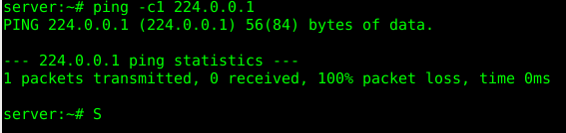
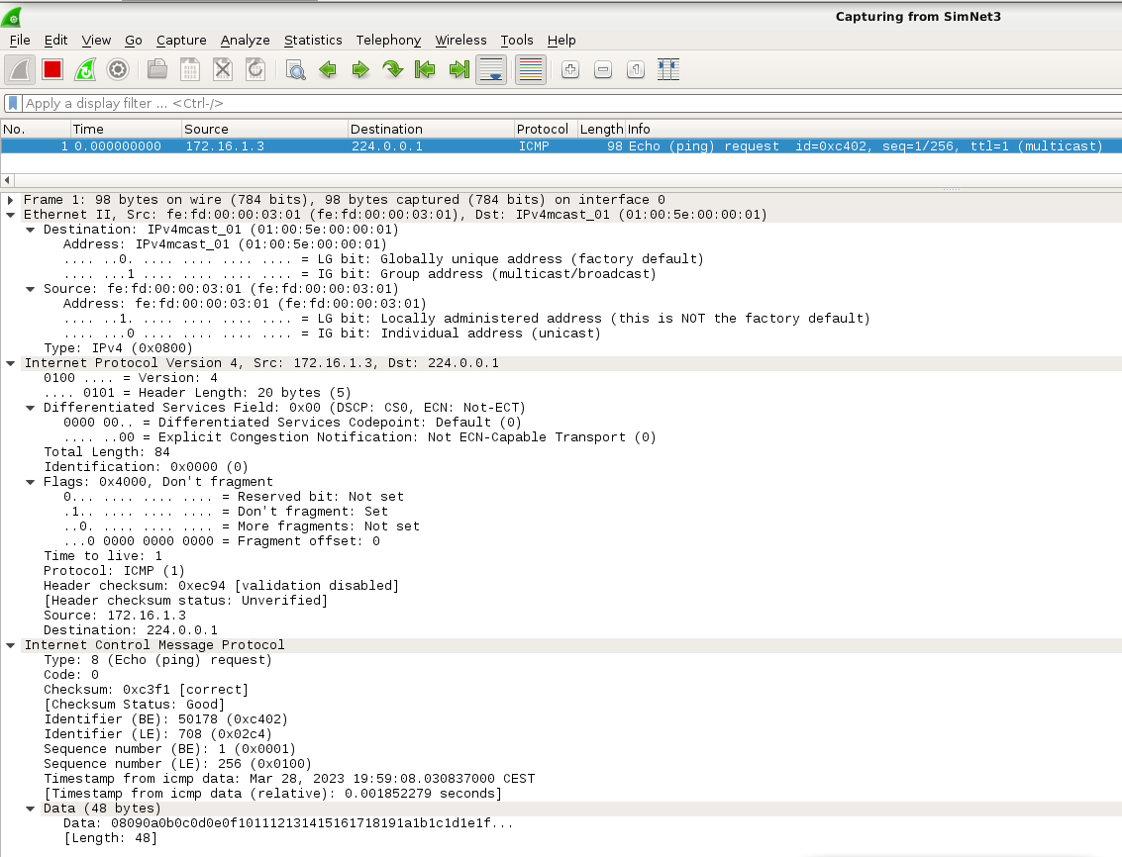
    - How many ICMP packets can you see in SimNet3? What type of messages?
We can see just 1 ICMP echo-request.
    - In the IP header, which is the TTL of this packets? What does this mean?
El TTL d’aquest paquet TTL=1, això significa que només pot passar per un node (R2) més abans de ser descartat per la xarxa o tornar al seu origen. Per tant, només podrà fer un intent, si aquest falla, es descarta el paquet.
    - In the IP header, which are the source and destination addresses?
Les @IP d’aquest paquet són: @s:172.16.1.3 / @d: 224.0.0.1 (server → hosts multicast)
    - In the Ethernet header, which are the source and destination addresses?
Les adreces MAC són: @s: fe:fd:00:00:03:01 / @d: 01:00:5e:00:00:01 (IPv4mcast_00:00:01)
    - Can you see the direct mapping in the MAC destination address?
Podem observar Mapeig Directe en l’@MACd:
@IPdmcst |  | 1110 0000 | 0 | 000 0000 | 0000 0000 | 0000 0001
@MACdm | 0000 0001 | 0000 0000 | 0101 1110 | 0000 0000 | 0000 0000 | 0000 0001
Tal com es pot veure, @MACd està construïda amb el prefix 01:00:5E (en HEX). Els 24bits restants corresponen a 0+23 bits menys significants de l’adreça IP multicast. En aquest cas en particular per @IP: 224.0.0.1, correspon @MAC: 01:00:5E:00:00:01.
As you can see, the destination MAC address is constructed by using the prefix 01:00:5E (in hex). The 24 remaining bits correspond to 0+23 least significant bits of the multicast IP address. In the particular case of the IP address 224.0.0.1, this corresponds to the MAC address 01:00:5E:00:00:01.
- Put a wireshark listening in SimNet3.
- Execute the following command in the server:
s e r v e r # ping −c1 232.0.0.1
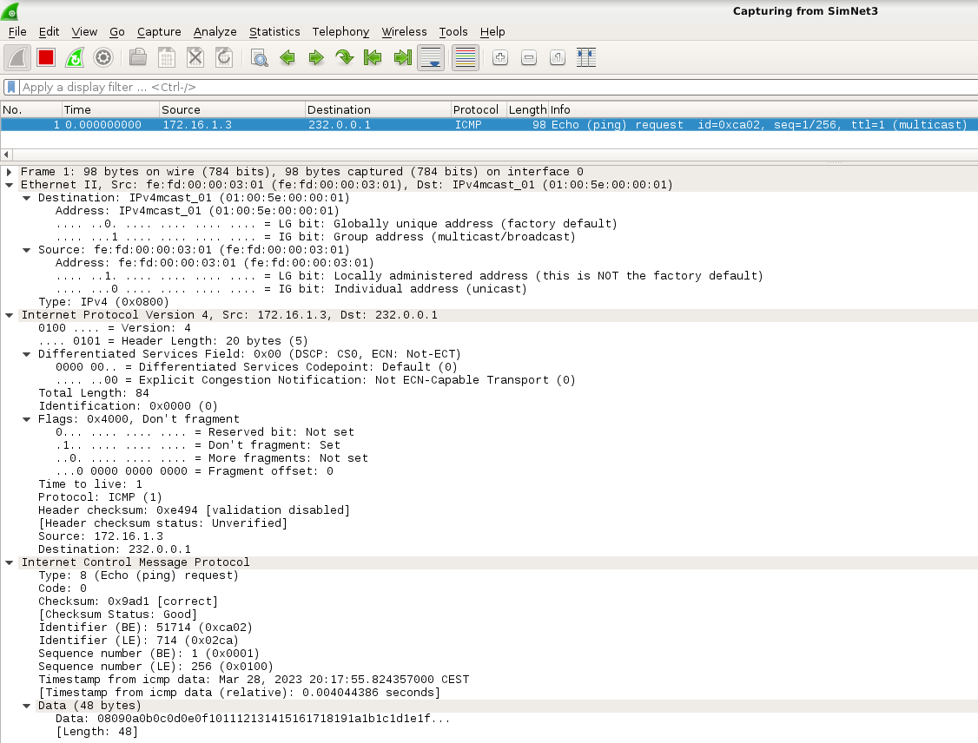
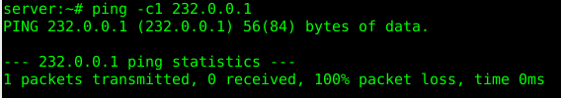
- In this ICMP packet, which is the destination MAC addresses?
@MACd: 01:00:5e:00:00:01 (la mateixa que abans)
- Can you see any ambiguity in this mapping? Which other addresses cause also this ambiguity?
Podem observar una ambigüitat en el procés de Direct-Mapping, ja que assigna la mateix @MAC a dos @IP diferents. Totes les adreces multicast que tinguin una estructura X.X0000000.00000000.00000001 tindran aquest problema.
- How can the system resolve this ambiguity?
El sistema resolt aquesta ambigüitat fent que el host comprovi l’adreça m/c IP i descartar els paquets amb una @IP no registrada. Podem observar que no hi ha paquets ICMP echo-reply, ja que el principal propòsit de multicast no es enviar pings, sinó que la majoria d’aplicacions multicast no requereixen cap tipus de resposta. Si més no, si es vol enviar pings multicast i rebre resposta, s’ha de desactivar un flag del sistema Lynux per a que no ignori els paquets ICMP de broadcast i multicast.
I suppose that you also noticed that there is no reply message for these messages. Just remark that the main purpose of multicasting is not sending pings, and most multicast applications do not require any answer. Anyway, as we want to send multicast pings and receive and answer for them, we have to disable a flag in your Linux system in order not to ignore broadcast and multicast ICMP packets.
- Put a wireshark listening in SimNet3.
- Execute the following commands in the server: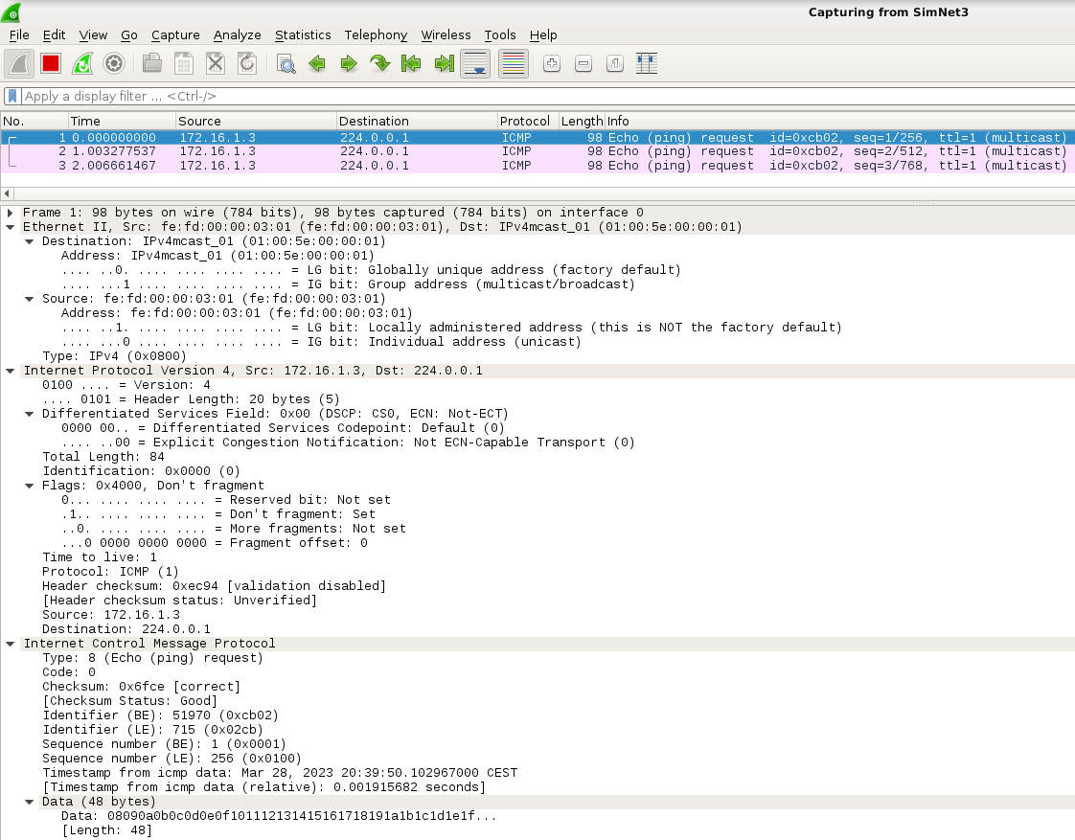
server# echo 0 > /proc/sys/net/ipv4/icmp_echo_ignore_broadcasts
server# ping −c3 224.0.0.1
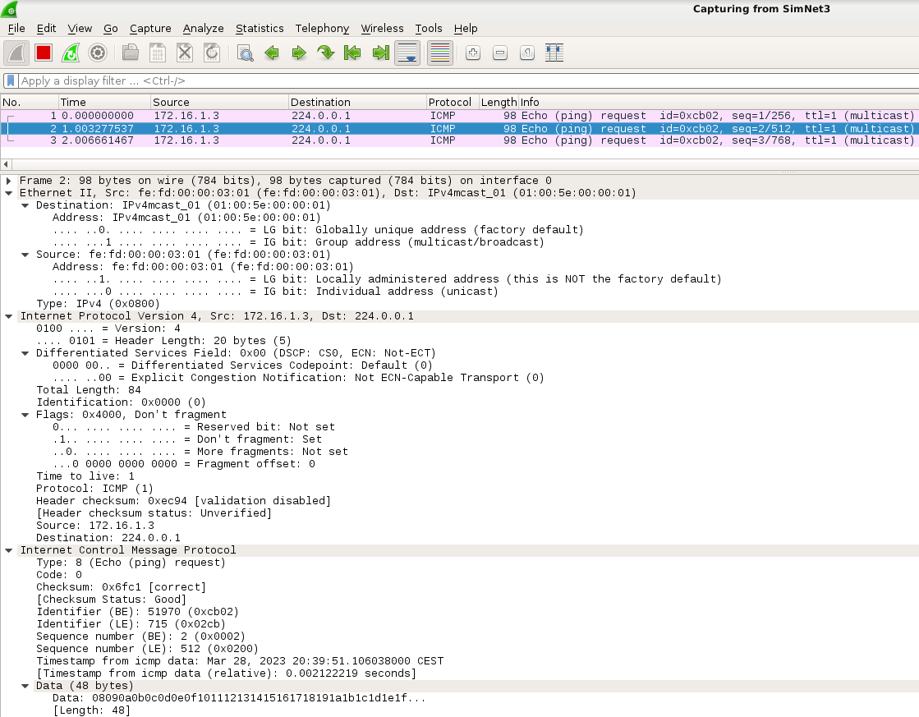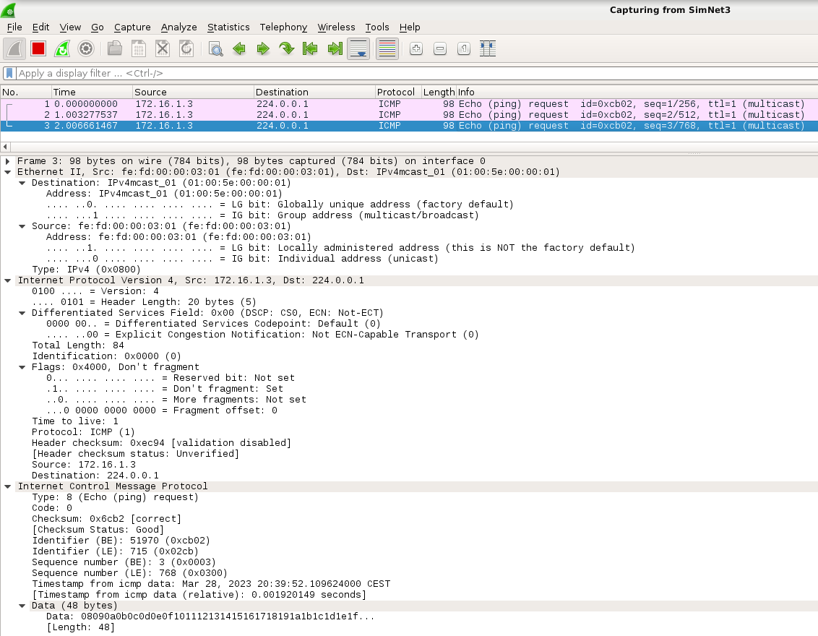
- Is the ping working? Who is answering to the ping?
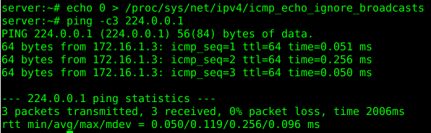
Esta funcionando, pero no se ve ninguna respuesta en la Simnet3, eso significa que nos esta contestando el propio host a través de la loopback.
- Can you see any reply message in SimNet3?
No podem veure els echo-reply ja que el server es contesta a ell mateix amb el loop-back.
- Now dissable the same flag in R2, and ping from server:
R2# echo 0 > /proc/sys/net/ipv4/icmp_echo_ignore_broadcasts
server# ping −c3 224.0.0.1
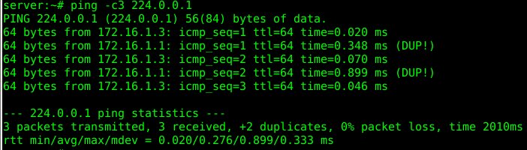
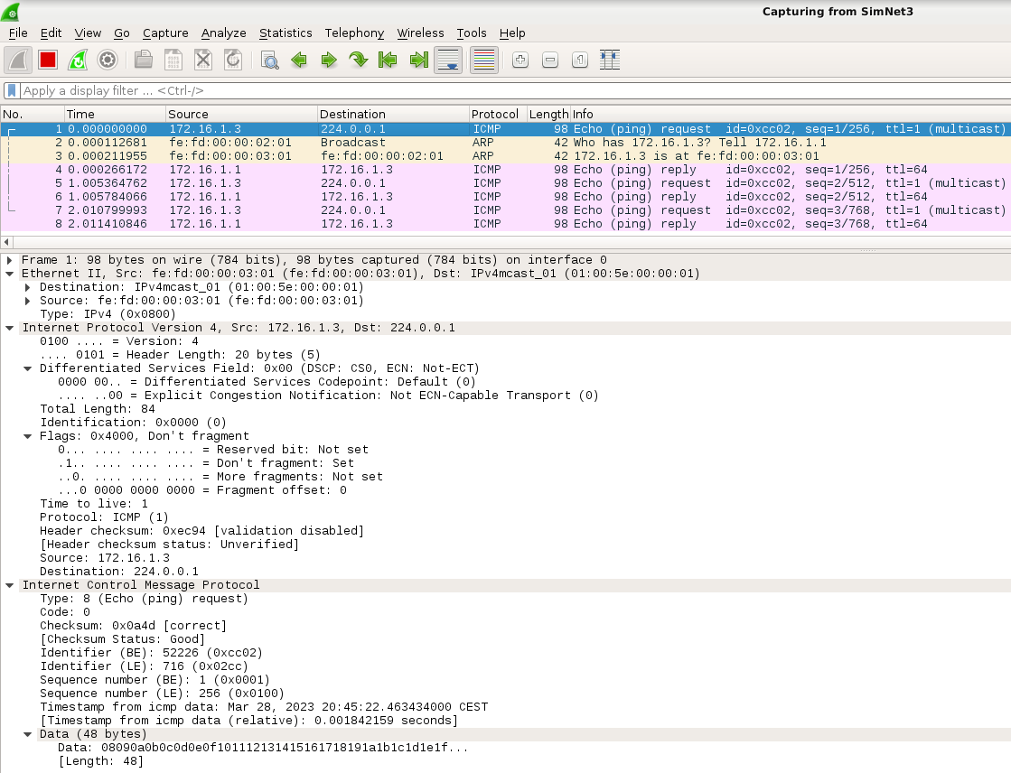
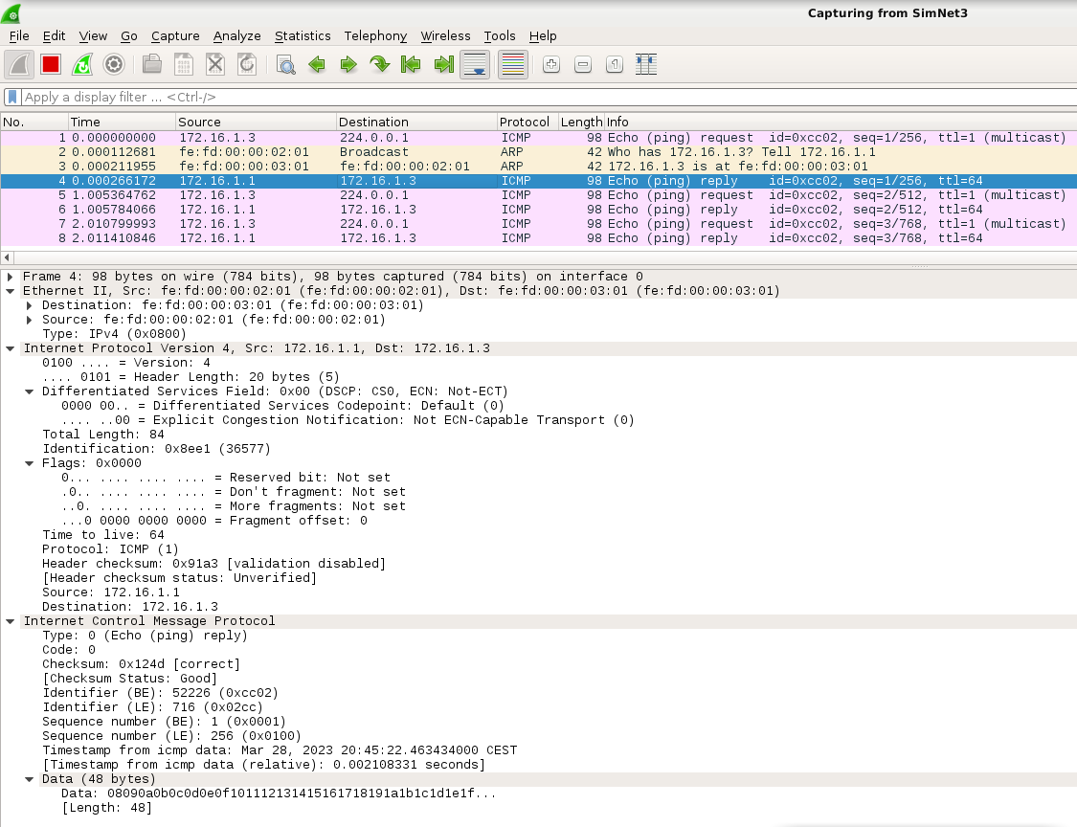
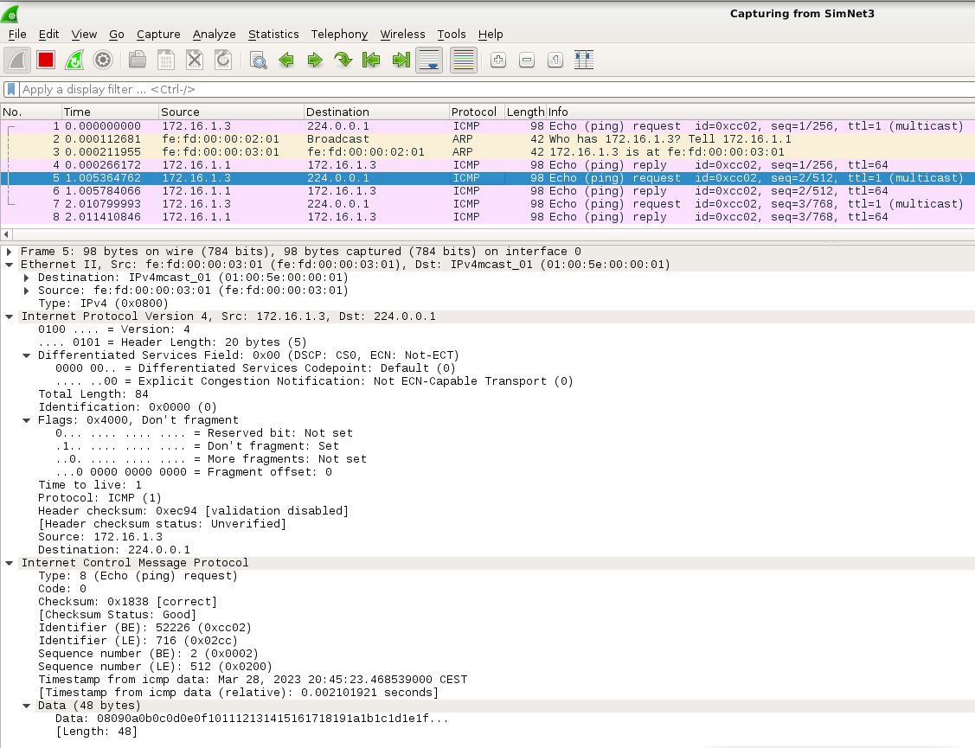
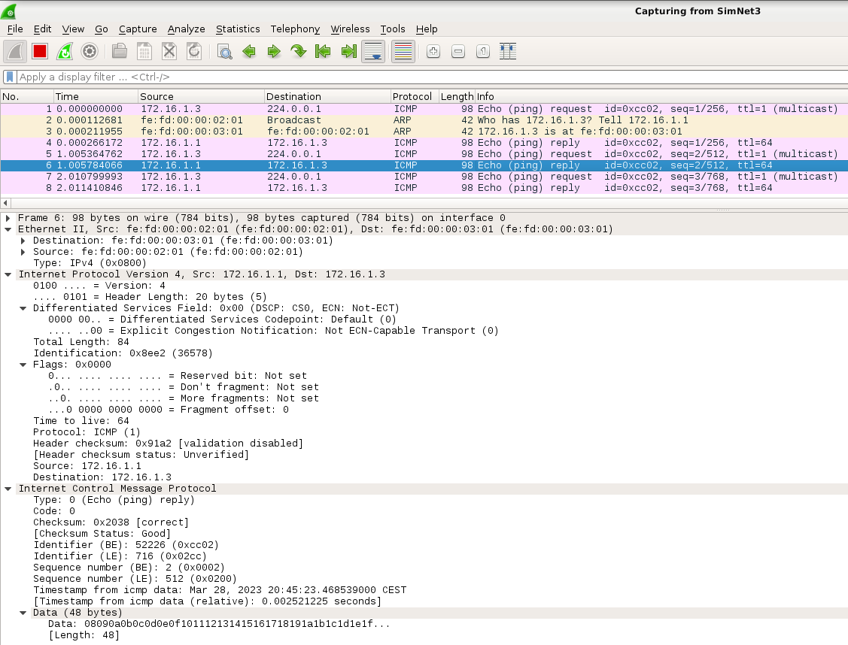
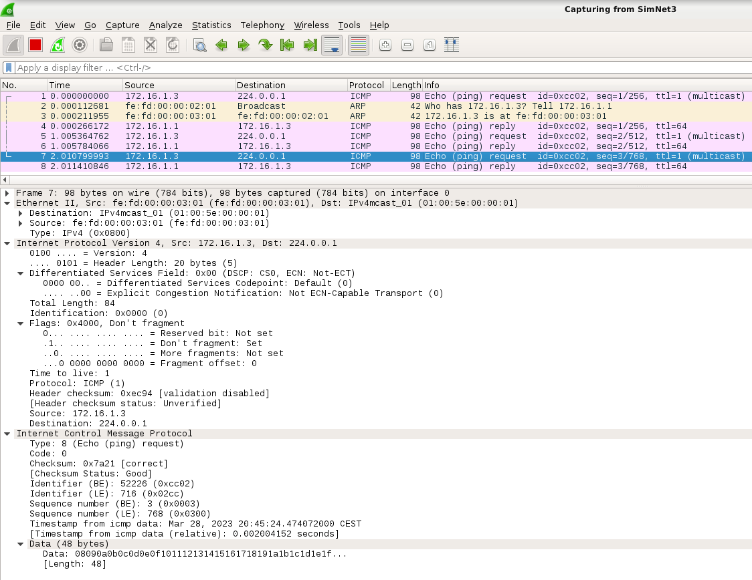
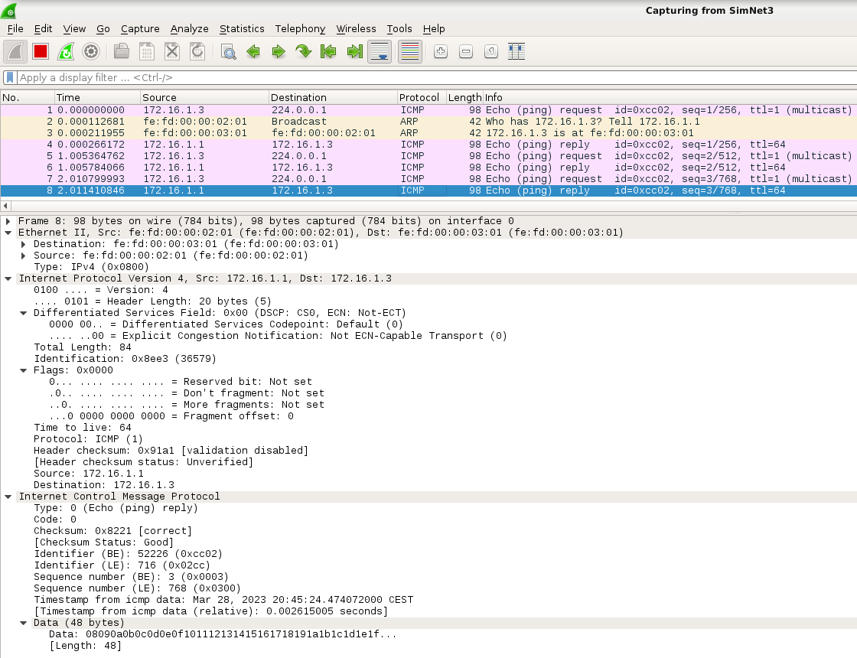
- Who is now answering to the ping?
Haciendo esto lo que obtenemos es que se nos tenemos replys duplicados por que nos contesta el R2 y el propio host por la loopback.
- Can you see any reply message in SimNet3?
Podem veure els 3 request i els 3 reply correctament.
- Are the answer packets sent in a multicast way?
Els paquets de resposta (Reply) no estan enviat amb multicast, sinó directament al host d’origen (server) des de R2.
Els request tenen un TTL=1 ja que al ser un servei multicast, si el paquet no es retransmet bé a la primera no ens interessa reenviar-lo, però els reply tenen TTL=64 perquè és el de per defecte, ja que aquest en una resposta forçada.

Multicast transmission in a subnet
We pretend to make a multicast transmission of a file between server and R2, which are located in the same subnet, but before this, let us present you some commands and files that may help you to analyze multicast.

Multicast configuration
There are some files in the system that offers to you some information about multicast interfaces and groups. Have a look to the following configuration commands and files³:
      - /proc/net/igmp: this file contains the groups to which the host has joined. If you have a look to this file in
server, you will see something like this:

server:~# cat /proc/net/igmp
Idx Device : Count Querier Group Users Timer Reporter 1 lo : 1 V3
010000E0 1 0:00000000 0
3 eth1 : 1 V3
010000E0 1 0:00000000 0
As you can see, this file shows you information about the interfaces that are joined to certain groups (the loopback interface lo and eth1 are joined to the group 010000E0. This notation seems odd, but it is quite typical. If you translate this hex string 010000E0 to decimal you will see that is equal to 1.0.0.224. Does it sound familiar to you? This way provides another way of denoting IP addresses, just changing the order of the octets. You can also see this same information by executing the command netstat -gn.
      - /proc/net/ip_mr_vif : this file contains the interfaces that are involved in multicast operations in the multicast router, and some statistics of usage (e.g. number of packets sent and received). If you see the contents of this file right now you will see the file is empty. This is totally normal, as multicast information can only be seen meanwhile there is a multicast flow being transmitted.
      - /proc/net/ip_mr_cache : this file shows the contents of the Multicast Forwarding Cache. As it happens in the previous file, if you have a look to this file right now, you will see nothing, as the file only shows active routes. Anyway, the way in which this file displays information is sometimes hard to read, so we recommend to use the command ip mroute show, which shows just the same information.

Transport protocol
ICMP is a layer-3 protocol whose aim is mainly reporting errors of the network layer, so it is not suitable as transport protocol to send data. So, which is the transport protocol to send information when using multicast? TCP does not support multicast, for several reasons. For instance, multicast is not a connection-oriented mechanism. Also, multicast is often used for applications such as audio and video streaming, where an occasional dropped packet is not a problem, so reliability offered by TCP may not be appropriate. For this reason, most of the times IP multicast uses UDP as transport layer protocol, and you are going to use it here in this lab session.
As you should know, UDP is an unreliable protocol by nature, meaning that UDP packets can be lost, duplicated or delivered out of order. In case of requiring reliability to distribute critical data during the transmission of multicast packets, it should be provided by the application layer, or by using other transport protocols, for instance the Pragmatic General Multicast (PGM) protocol (RFC 3208), which have been developed to detect losses and retransmit packets. In this lab session, we are not going to deal with reliable multicast.

udp-sender
You are going to use udp-sender and upd-receiver to make the transmission of a video file via multicast. Prior to start this transmission, let us test the behavior of these commands. We will start with udp-sender, here you have the available options, extracted from the man page.

udp-sender [--file file] [--full-duplex] [--half-duplex] [--pipe pipe] [--portbase portbase] [--blocksize size] [--interface net-interface]
[--mcast-addr data-mcast-address] [--mcast-all-addr mcast-all-address] [--max-bitrate bitrate] [--pointopoint] [--async] [--log file]
[--min-slice-size min] [--max-slice-size max] [--slice-size] [--ttl time-to-live] [--fec stripesxredundancy/stripesize] [--print-seed]
[--rexmit-hello-interval interval] [--autostart autostart] [--broad- cast] [--min-clients clients] [--min-wait sec] [--max-wait sec]
[--nokbd] [--retriesUntilDrop n]

As you can see, udp-sender offers several options to send information via broadcast or multicast. It can be used in a unidirectional or bidirectional way, and it is possible to tune many application and network parameters, like the TTL, the maximum bitrate, retransmissions, FEC (Forward Error Correction) codes, etc. Do not worry because in the lab session we are not going to use all these options, but it would be a good idea to have a look to them so you can understand their meaning. You must know that this software uses two multicast groups to enable the transmission:
- A multicast group to send data: in our case you will use the multicast group 232.43.211.234.
- A multicast group to control and add reliability, and you will use 225.1.2.3. So let us start testing udp-sender:
- Open another console of server, that will be used to see the status of this host meanwhile you are sending the video. Go to the HOST machine and execute:
HOST$ simctl ipmulticast get server 1
server# cat /proc/net/igmp
This command will open console 1 of server (you where previously working using console 0). Now, in this console 1, see the contents of the file /proc/net/igmp:
- Put a wireshark listening in SimNet3.
- In this case, server will act as video server. So, go to console 0 and execute the following command:
server# udp-sender --file=./big_664.mpg --min-clients 1 --portbase 22345 --nopointopoint --interface eth1 --ttl 1 --mcast-addr 232.43.211.234 --mcast-all-addr 225.1.2.3
- The previous command prepares server to transmit via multicast the locally stored video file big_664.mpg. Have a look to the manual of this command (man udp-sender) and explain each of the options used.
- In SimNet3:
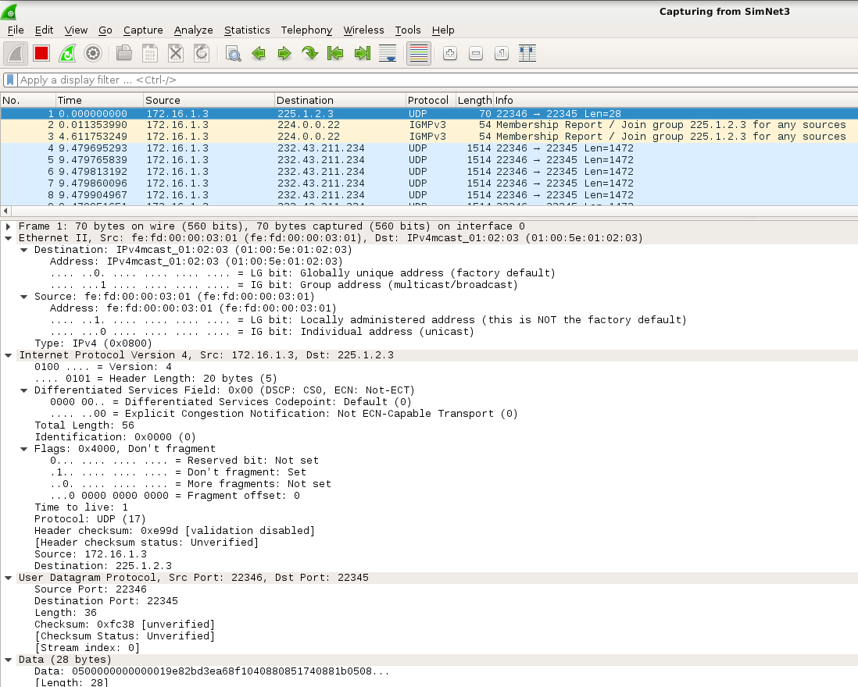
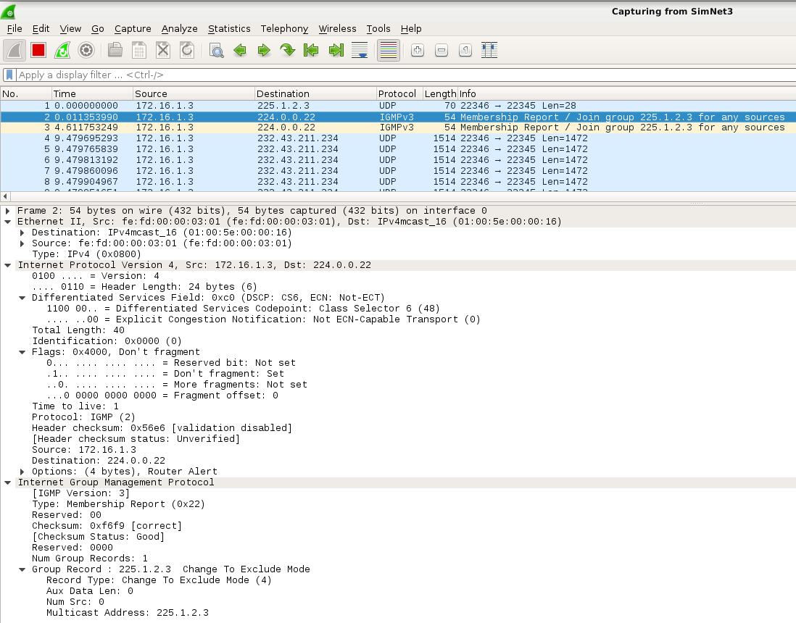
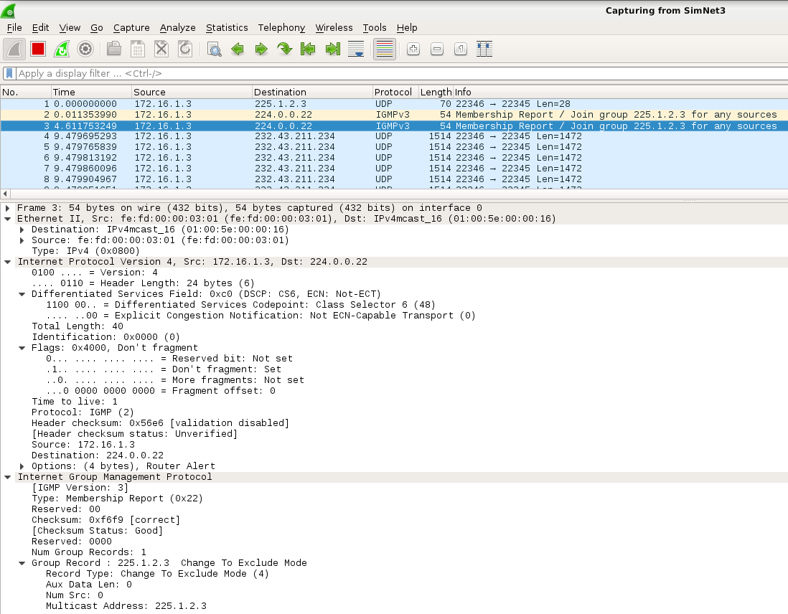
Cuando pulsamos otra vez “Intro” en el terminal server.0 se transmite el video y se pueden observar el fichero como podemos ver en los siguientes paquetes UDP.
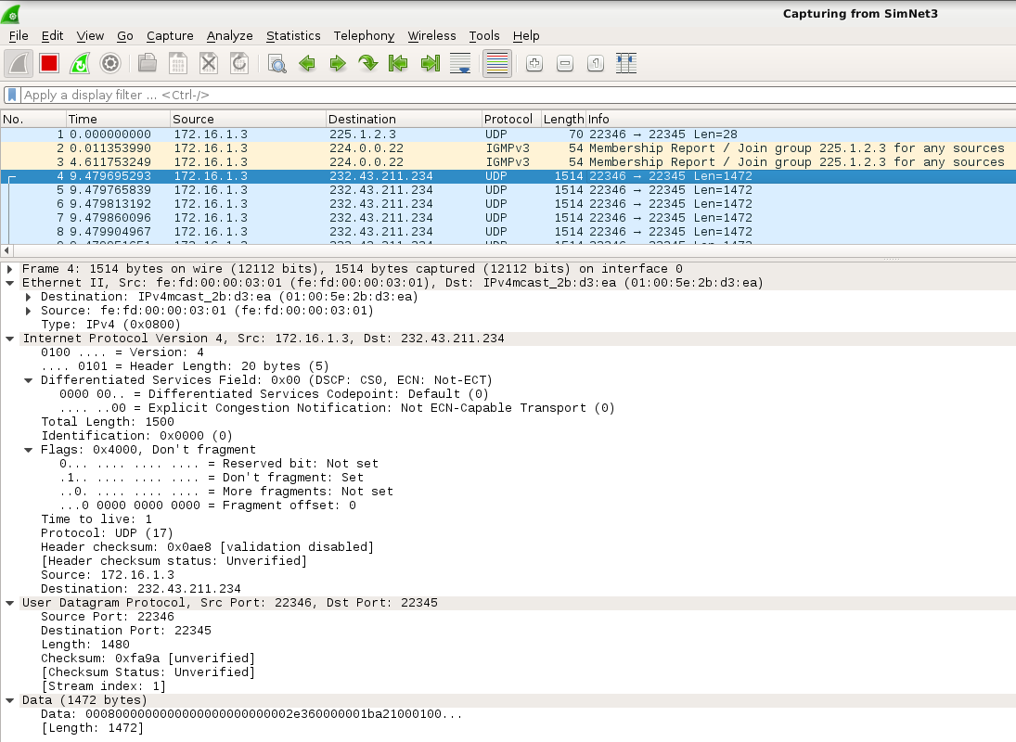
- How many packets can you see? Which type of packets?
Podem veure 3 paquets: el primer un paquet UDP i dos paquets IGMP.
- In the UDP packet, which is the destination address? and the TTL?
Paquet UDP (172.16.1.3 → 225.1.2.3) amb TTL=1 (especificat per l'aplicació)
- Which are the port numbers?
Paquet UDP → SPort: 22346 / DPort: 22345
- Can you see any IGMP packet? Which type of packet? Which is the IP destination address of this IGMP messages?
Dos paquets IGMP (172.16.1.3 → 224.0.0.22) Membership Report / Join group 225.1.2.3 for any sources. L’@ 224.0.0.22 pertany al grup multicast IGMP (inici pràctica).
As you can see, there is an UDP packet sent towards the control multicast group, whose objective is contacting with the destination. As the client has not been launched, the server just waits to send the video. Notice that the TTL value of this IP packet is 1, as specified by the application. In this particular case, the -ttl 1 option is optional, because applications that do not specify the TTL should put 1 as default value for multicast packets (have a look to RFC 1112). However, remember to put the proper TTL when trying to reach remote destinations.
There are also a couple of IGMP messages, in which the server tries to join the control multicast group. As there is no multicast router, there is no answer to these messages.
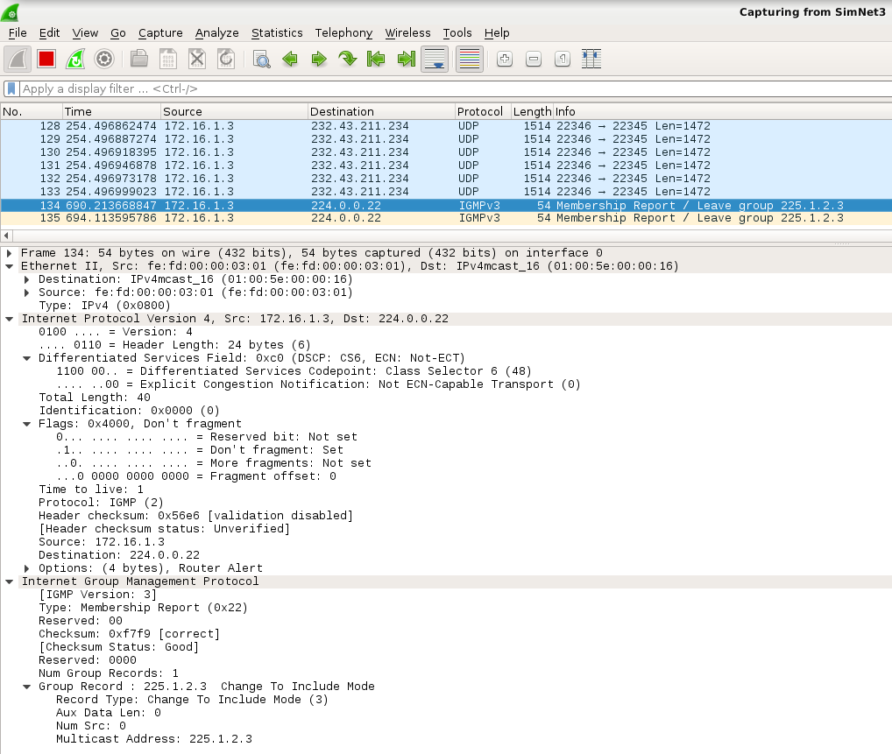
- Now have a look to the console 1 of server, and again see the contents of the file /proc/net/igmp.
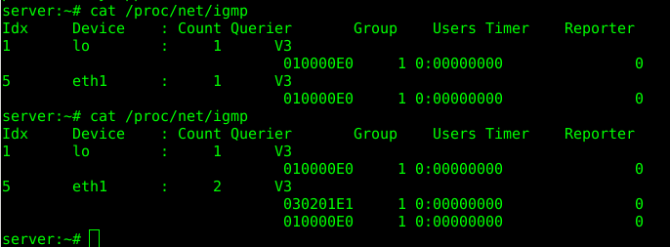
- Can you see any difference?
- What is the hex and the dot-decimal notation of the newly added multicast group?
La diferencia que podem observar és que ara la interfície eth1 també esta connectada al grup 030201E1 → 3.2.1.225 // grup multicast de control.
- Go to console 0, and close the server by typing Control+C.
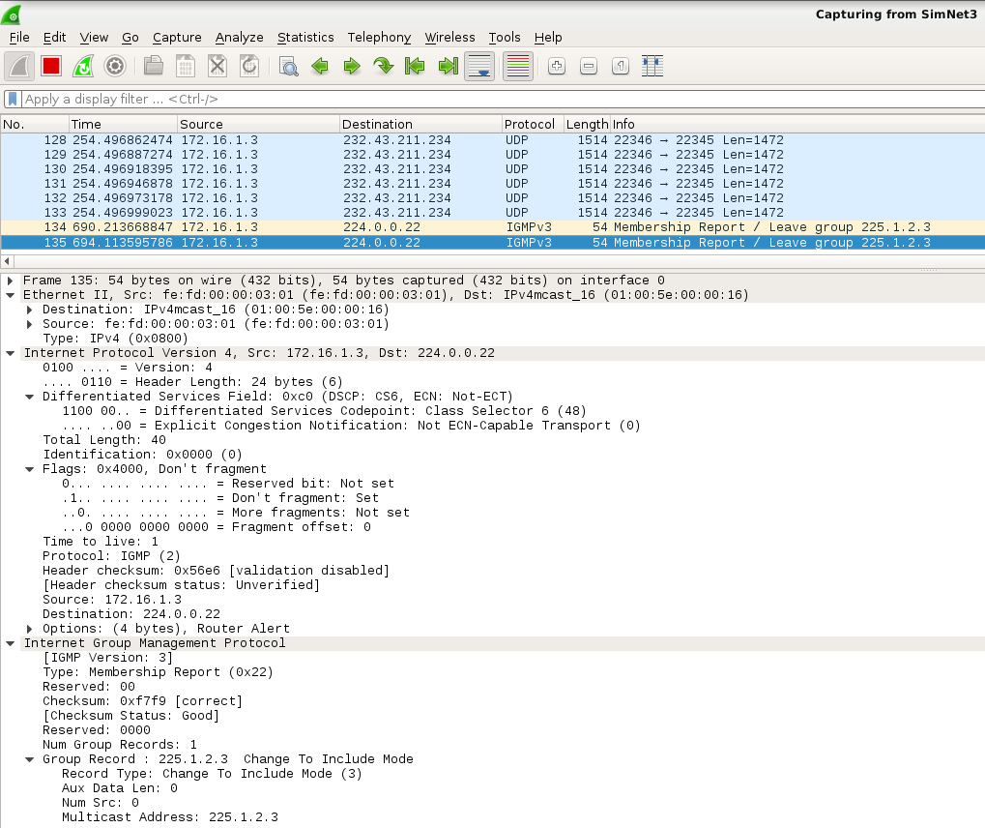
- Can you see in SimNet3 any new IGMP message? Which type?
Dos paquets IGMP (172.16.1.3 → 224.0.0.22) Membership Report / Leave group 225.1.2.3.
Com podem veure, quan tanquem el udp-sender, el server (the sender) abandona el grup de control enviant 2 paquets IGMP Leave Messages. Una altra vegada, com que no hi ha cap router multicast, aquests missatges no reben resposta.
- After closing, can you see again any change in the /proc/net/igmp file?
Ara, la connexió de eth1 a 030201E1 ha desaparegut.
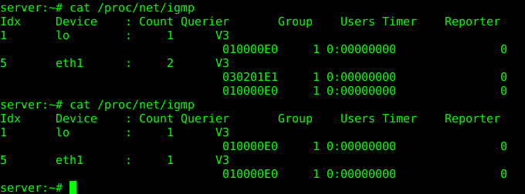
As you can see, when closing udp-sender the sender leaves the control group by sending two IGMP Leave Messages. No answer will be sent to these messages as there is no multicast router.

upd-receiver
The command udp-sender works with its corresponding client, udp-receiver, here you have the available options, extracted from the man page:
udp-receiver [--file file] [--pipe pipe] [--portbase portbase] [--interface net-interface] [--log file] [--ttl time-to-live]
[--mcast-all-addr mcast-all-address] [--nokbd] [--exitWait millisec- onds]
Let us start testing udp-receiver:
      - Open another console of R2, that will be used to see the status of this host meanwhile you are launching
udp-receiver. Go to the HOST machine and execute:
HOST$ simctl ipmulticast get R2 1
This command will open console 1 of R2 (you where previously working using console 0). Now, in this console 1, see the contents of the file /proc/net/igmp:
server# cat /proc/net/igmp
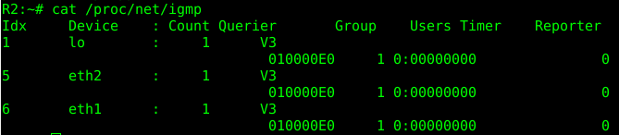

    - Which interfaces in R2 are joined to group 224.0.0.1?
Les interfícies del grup 224.0.0.1 són lo, eth2, eth1
      - Now open two wiresharks, one listening in SimNet2 and another one in SimNet3.
      - In this case, R2 will act as a host, receiving the video. So, go to console 0 and execute the following command:

R2# udp-receiver --file=big_664.mpg --mcast-all-addr 225.1.2.3 --ttl 1 --portbase 22345

This command prepares R2 to receive a video via multicast, which should be stored locally with name big_664.mpg.
      - Have a look to the wiresharks.
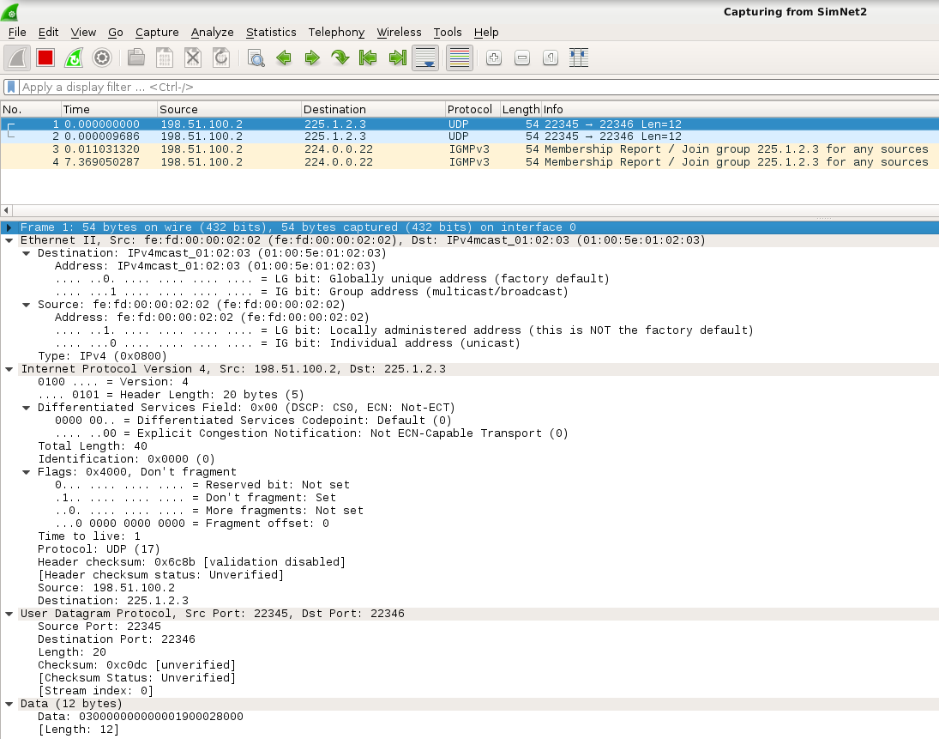
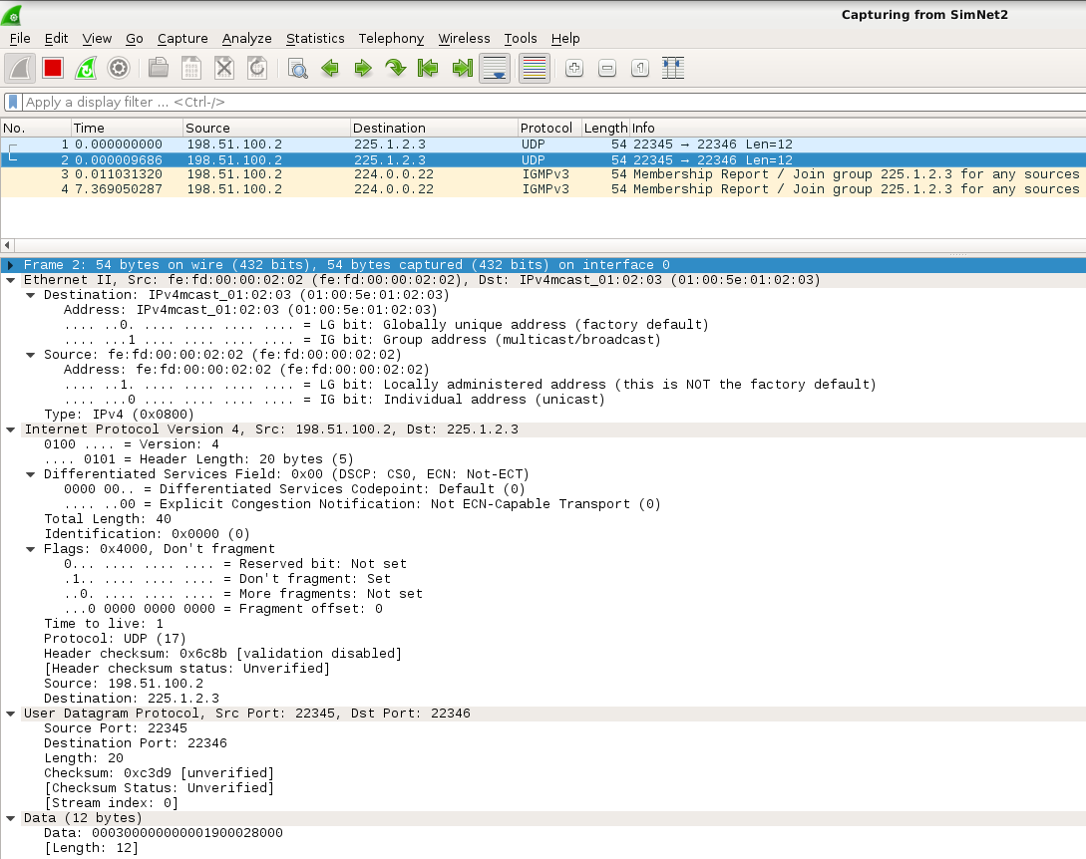
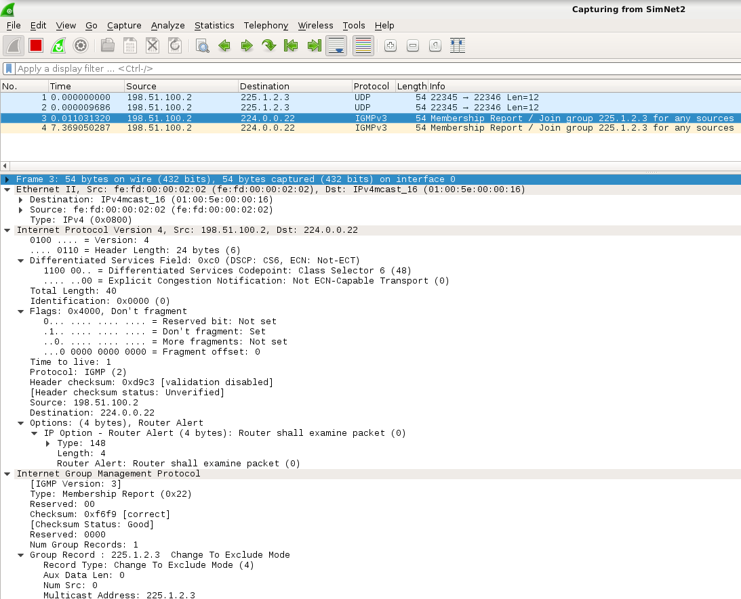
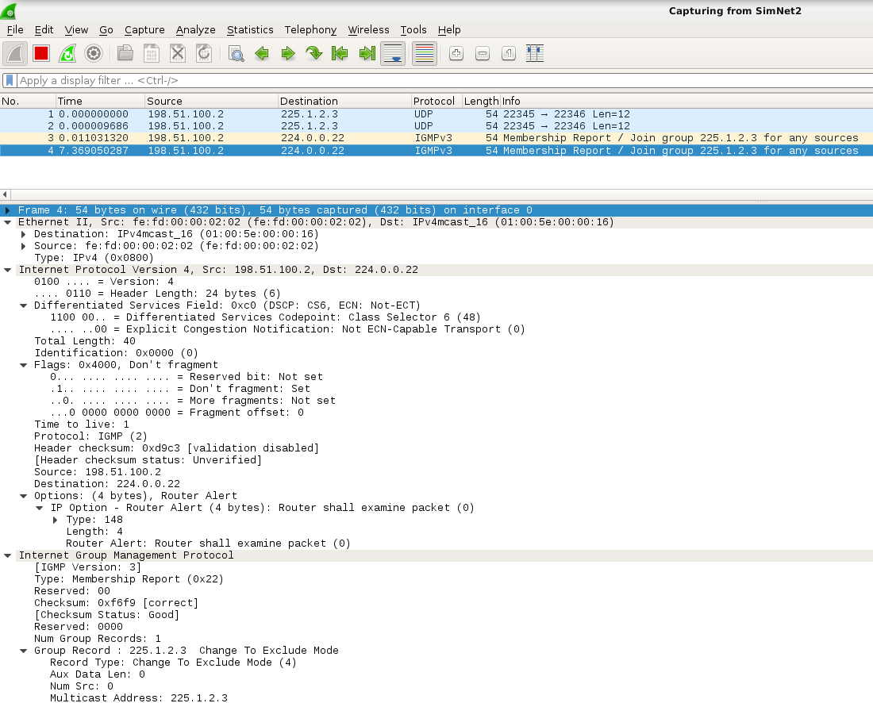
- How many packets can you see in SimNet3? and in SimNet2?
A SN3 no veiem res, i a SN2 veiem dos paquets UDP i dos paquets IGMP (198.51.100.2 → 224.0.0.22)
- Why do you think that these packets are in this network and not in the other?
Por el routing estatico que tiene configurado el host, en este caso el router, y como en le comando no le decimos nada, coge la interfaz que corresponde con el unicas route por defecto. Mira el routing estatico
By the static routing that has configured the host, in this case the router, and as in the command we do not say anything, takes the interface that corresponds to the default route unicas.
Tambien podemos ver que R2 se ha unido al grupo de control especificado en el comando del upd-sender.
We can also see that R2 has joined the control group specified in the upd-sender command.
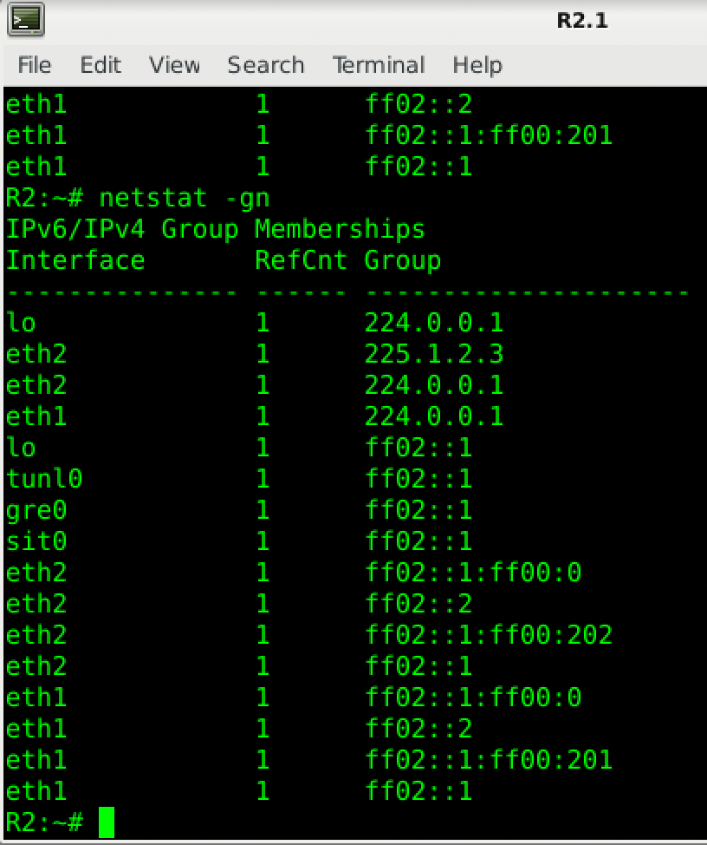
According to RFC 1112, applications sending multicast packets should choose which are the output interfaces of these packets, and if not, the operating system will choose them. The application udp-receiver has an option to select the interface to send packets, but you did not use it, so the application has chosen the interface that corresponds to the default unicast route.
Later you will change this to make multicast packets to go through SimNet3, but now let us have a look to packets in SimNet2 using wireshark.
- In the UDP packets, which is the destination address? and the TTL?
Dos paquets UDP (198.51.100.2 (eth2/R2) → 225.1.2.3) (TTL=1)
- Which are the port numbers? Are these numbers familiar to you?
(SP:22345 / DP: 22346) Aquests ports corresponen als anteriors intercanviats.
- Can you see any IGMP packet?
Podem veure dos paquets IGMP Membership Report / Join group 225.1.2.3 for any sources.
As you can see, there is a couple of UDP packets sent towards the control multicast group, whose objective is contacting with the server. As the server has not been launched, nothing happens. There are also a couple of IGMP Membership Report messages, in which R2 tries to join the control multicast group. As there is no multicast router, there is no answer to these messages.
      - Now have a look to the console 1 of R2, and again see the contents of the file /proc/net/igmp.
- Can you see any difference?
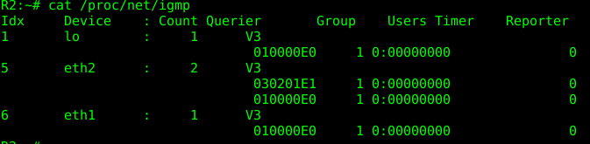
La diferencia que podem observar és que ara la interfície eth2 també esta connectada al grup 030201E1
      - Go to console 0, and close udp-receiver by typing Control+C.
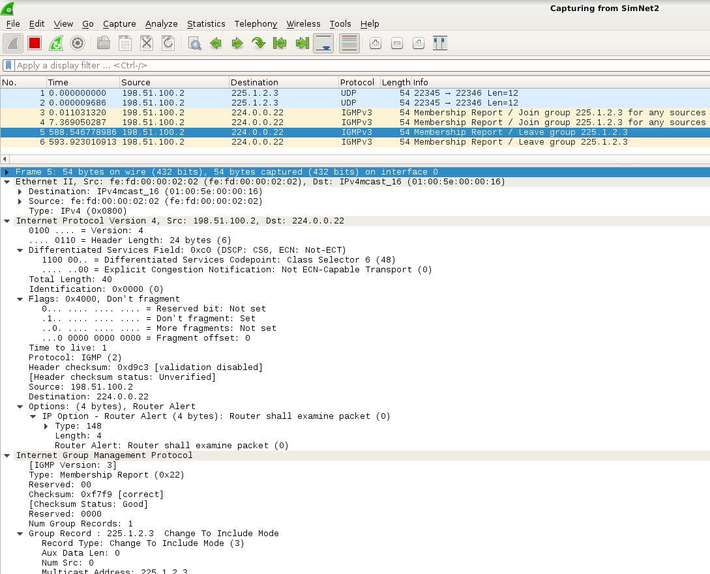
- Can you see in SimNet2 any new IGMP message? Which type?
Enviamos dos mensajes porque igmp no tiene reliability entonces enviamos dos
- After closing, can you see again any change in the /proc/net/igmp file?
Ara, la connexió de eth2 a 030201E1 ha desaparegut.
As you can see, when closing udp-receiver R2 leaves the control group by sending two IGMP Leave Messages. No answer will be sent to these messages as there is no multicast router.

Sending the video file in the subnet
Now that you know how udp-sender and udp-receiver behave, it is time to make a real distribution of a video file via multicast:
      - Put a wireshark listening in SimNet3.
      - Go to console 0 of server and execute again the following command:
server# udp-sender --file=./big_664.mpg --min-clients 1 --portbase 22345 --nopointopoint --interface eth1 --ttl 1 --mcast-addr 232.43.211.234 --mcast-all-addr 225.1.2.3
      - Go to console 0 of R2 and execute the following command, now forcing the packets to be sent to the proper interface:
R2# udp-receiver --file=big_664.mpg --mcast-all-addr 225.1.2.3 --ttl 1 --interface eth1 --portbase 22345
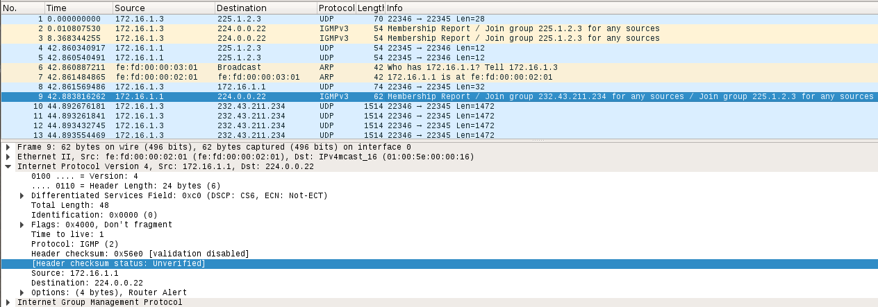

- Was the transmission ok?
Everything went well.
- How many packets can you see in wireshark?
As you have seen, the transmission went ok, but now it is time to focus on some key point in this transmission.
      - Let us start analyzing the four initial UDP packets of short-length.
- What do you think is the purpose of these initial packets?
The Initial paquets are send as a signalling data from the sender to the receivers. But in this case as the sender is the first one to connect , there is no answer to those paquets.
- In the first UDP packet sent by server, which is the IP destination address?
Destination: 225.1.2.3 is the control group
- Do you recognize anything inside of the DATA field of this packet? Try to convert 232.43.211.234 in hex.
E82BD3EA…. yes it can be found in the first packet data due to is informing to the ones which are connected waiting to connect to the data multicast group.
- At the time this first packet was sent by the server, was R2 listening at the control multicast address?
No.
- What do you think is the purpose of the second and third UDP packets (the ones sent by R2)?
El objetivo del segundo y tercer paquete UDP del R2 es obtener la dirección multicast destinada para transferir los datos. The purpose of the second and third UDP packets from R2 is to obtain the multicast address intended to transfer the data.
- At this time, does R2 know which is the data multicast group that server is going to use to send the video?
El R2 no sabe nada hasta que el sender le responde con unicast paquet pasandole la direccion multicast de datos.
R2 does not know anything until the sender responds with a unicast packet passing it the multicast data address.
- Have a look to the fourth UDP packet. Is it a multicast or unicast packet? What is the purpose of this message? Do you recognize anything in the data field of the packet?
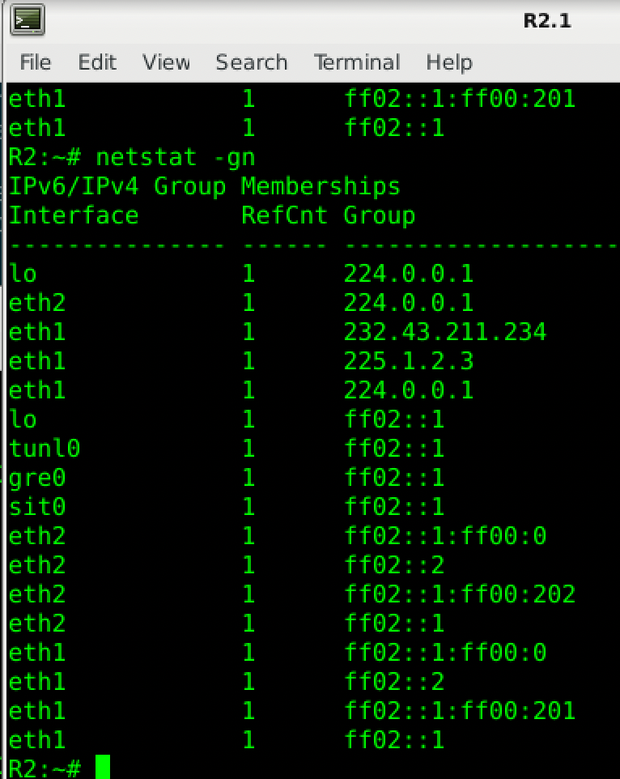
Is a unicast packet, with the purpose of sending the multicast data address to the new receiver that has contact with sender. In the data field you find the multicast data address.

As we can see the R2 has join to the control group 225.1.2.3 and 232.43.211.234 in the interface eth1.

As you can see, this first dialogue of four short-length UDP packets is used for sender and receiver to mutually recognize themselves and exchange key information about the transmission. The sender knows which is the data multicast group, but not the receiver. Until the last fourth packet the receiver is not informed (in a unicast way) about the data multicast group that has to join. For this reason, the following message is an IGMP Membership Report of R2 joining both groups. You can verify that R2 is joined to both groups by having a look to file /proc/net/igmp meanwhile the file is downloading.
      - Regarding the transmission of the video (look at packets that are full of information):
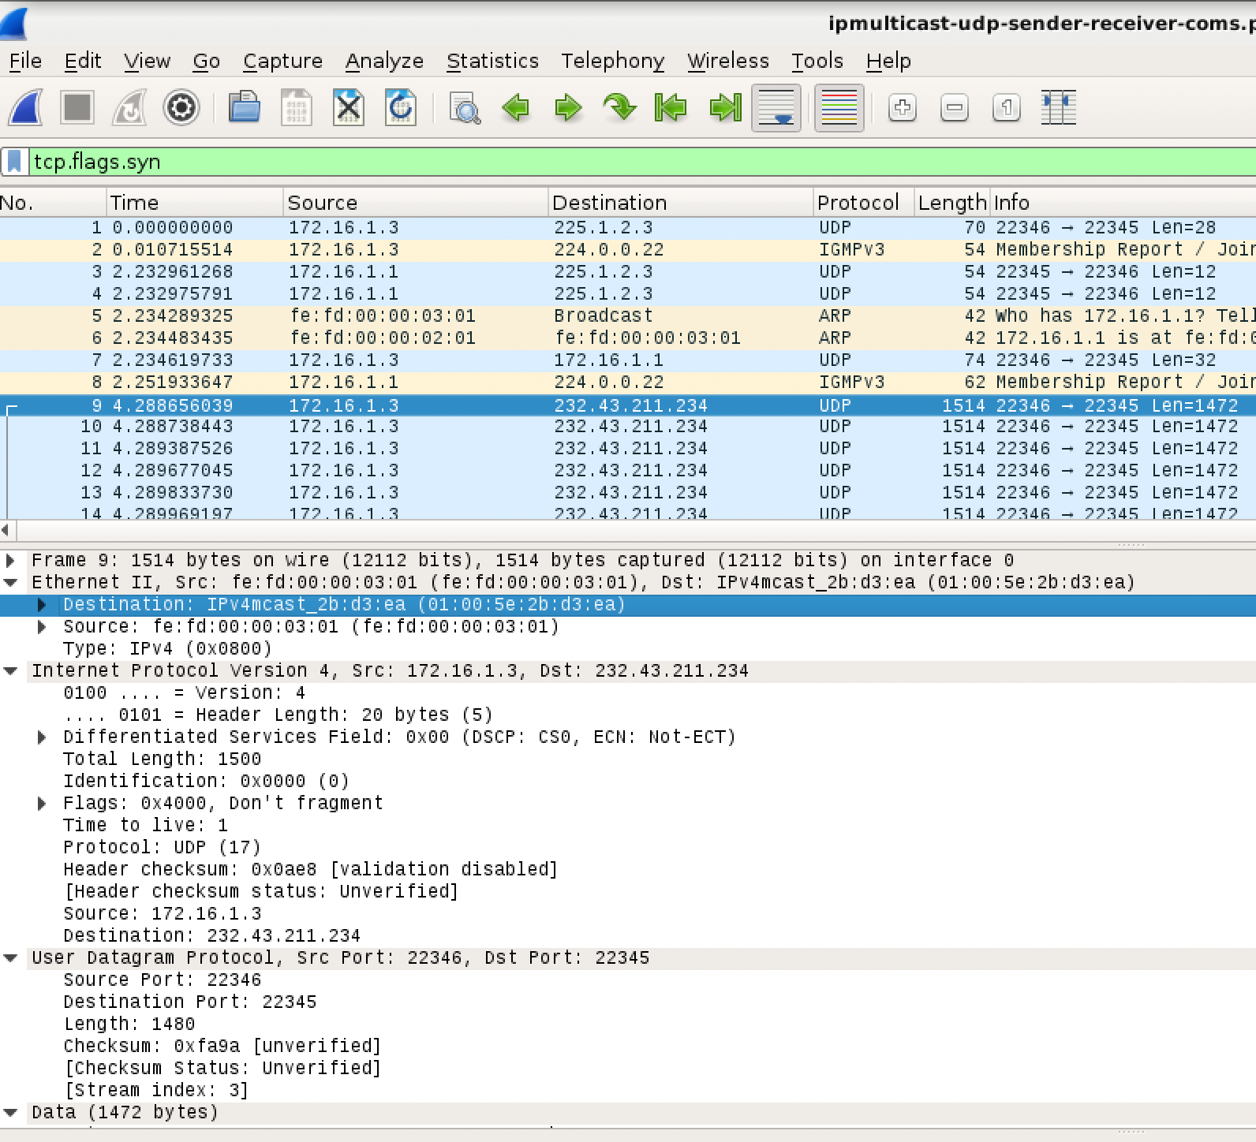
- Which is the destination IP address of these packets?
Dst ip: 232.43.211.234
- What is the size of most of this data packets?
The size without ethernet header is 1500B = 20B IP header + 8 B UDP header + 1472B data
- There are some unicast packets from R2 to server. What do you think is the purpose of these feedback packets?
To give feedback of the transmision that is going well
As you have seen, server sends the video by means of several UDP packets (full of data) with destination address 232.43.211.234. There are also some feedback unicast packets from R2 to server, used for reliability purposes⁴. Finally, both sender and receiver leave the corresponding multicast groups by sending IGMP Leave Messages. Now you know how to transmit information via multicast in a subnet. However, you know that most remote locations are far away, so routers should be used to reach them. It is time you go a step further, trying to do the same thing, but now involving multicast routers during the transmission.

Multicast and routing
In previous sections you only used the virtual machines in SimNet3, but now you will use the rest of the scenario. Remember that in the scenario of Fig 1 you have three multicast islands (SimNet0, SimNet3 and SimNet5) connected through a public network. There are some multicast routers (R1, R2 and R3), and a router without multicast capacities (RC). We mentioned that multicast islands were connected via GRE tunnels, but in fact you are going to create them right now. There should be a GRE tunnel between R1 and R2 called tunnel0, and another one between R3 and R2 called tunnel1.

Configuring GRE tunnels
In a previous lab session you learned how to configure and test IPIP tunnels. Unfortunately, Linux does not directly support multicast transmission via IPIP tunnels, and for this reason we are going to use GRE tunnels. If you want to know more about GRE tunnels, you can read RFC 1701 and RFC 1702.
You are not going to configure these tunnels manually, but using a script. Anyway, here you have a summary of the command that should be executed in the encapsulator and decapsulator to do so (you DO NOT have to execute them):
      - Configure the tunnel interface by means of the command ip tunnel. Tunnels have to work in gre mode. As an example, in R2 the command to execute:
R2# ip tunnel add tunnel0 mode gre local 198.51.100.2 remote 192.0.2.2 dev eth2
      - Activate the new virtual interface of type tunnel. To do so, it is necessary to assign an IP address to it (for instance, by means of the ifconfig command). In Linux, it is necessary to assign an IP address to any interface if we want it to properly work. Just as an example:
R2# ifconfig tunnel0 192.168.110.1
      - Update the routing table to make the proper packets to be routed towards the tunnel (for instance, by means of the route command). Just as an example:
R2# route add −net 192.168.0.0/24 dev tunnel0
To create both tunnels automatically, go to the console of your HOST machine, and execute:
HOST$ simctl ipmulticast exec addtun
After creating the tunnels, you have to verify that they properly work.
      - Put a wireshark listening to interface SimNet2.
      - Send a ping from the server to host2.
server#: ping -c1 192.168.0.2
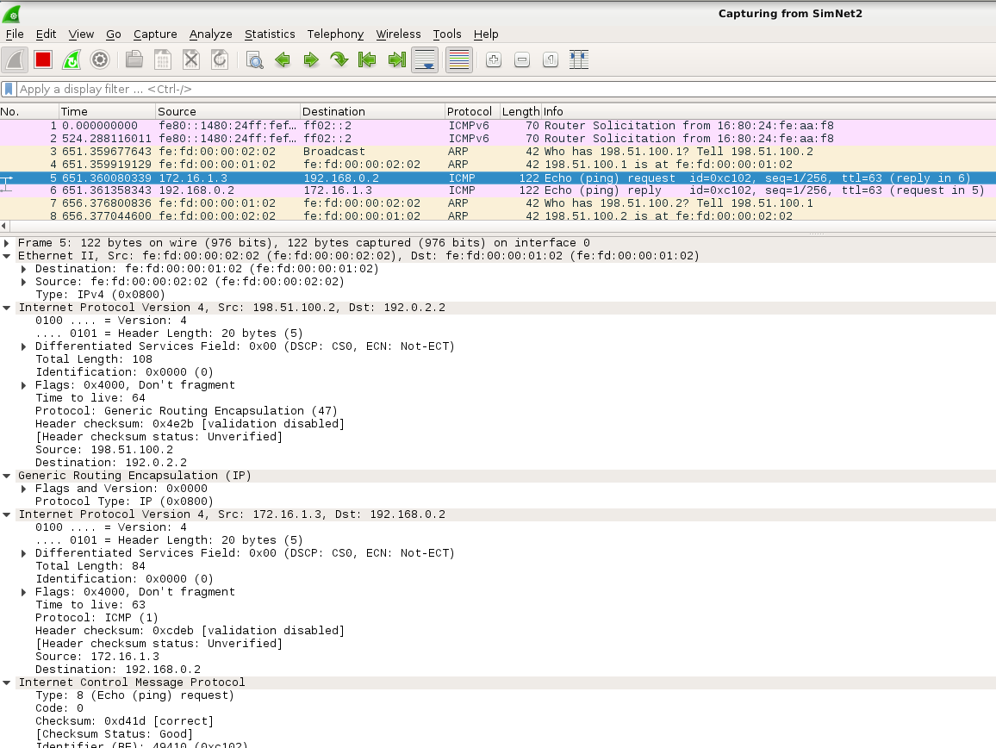
- Is the ping working?
El ping funciona correctament
- Can you see packets in the wireshark? What type of packets? Describe the headers you see.
Al wireshark podem veure un Echo request i un echo reply. Podem veure la capçalera Outer (198.51.100.2 → 192.0.2.2) i la Inner (172.16.1.3 → 192.168.0.2).
- Regarding the IP outer header, which are the source and destination addresses?
La Inner te les direccions que hem establert nosaltres com a origen i destí.
- Which is the size of the GRE header?
El tamany de la capçalera GRE és fixe, i pertany a 4B
- Which is the source and destination addresses in the inner header?
(1st header IPv4)
@IP_inner_sr = 172.16.1.3(server)
@IP_inner_dst = 192.168.0.2 (host2) private @source

      - Send also a ping from the server to host4 to verify that tunnel1 works.

server#: ping -c1 192.168.5.4 // ping al host4
El ping funciona correctament (request-reply): Inner (172.16.1.3 → 192.168.5.4) i Outer (192.168.5.4 → 172.16.1.3)
If you detect any kind or error about any of both tunnels tunnel0 and tunnel1, contact the professor to verify if there is any error in the machine or in simctl.

Multicast and ICMP
Just in previous sections you used pings to test the tunnels and to send multicast packets in the subnet. In both cases, pings were used just for easiness, and because you are very used to send and analyze “ICMP Echo Request” and “ICMP Echo Reply” messages using wireshark. Anyway, remember that ICMP is not only to send pings, it is the protocol intended to report the errors of the network. However, you must know that ICMP is barely used when sending multicast traffic. As clearly stated in RFC 1112 “ Host Extensions for IP Multicasting”:
An ICMP error message (Destination Unreachable, Time Exceeded,
Parameter Problem, Source Quench, or Redirect) is
never generated in response to a datagram destined to an IP host group.
These error messages are in fact the most typical ones, so this means that ICMP is not going to help you during the sending process of multicast packets, sending errors in case you commit a mistake. You are not going to receive any message like “Host Unreachable”, “Fragmentation Needed”, or “Time Exceeded” due to an error generated by a multicast packet. Next, you are going to deal with multicast and IP tunneling, so the scenario is prone to errors generated by TTL and MTU problems (as you noticed in the IP tunneling lab session). So, take this into account when configuring the network and when sending multicast packets. You should pay special attention when defining the TTL in each multicast packet (the scope of the packet), and also the size of them so they can traverse tunnels properly.

Multicast static routing: smcroute
So you are ready to create the multicast routing tree from the sender to all the receivers. You are not going to use dynamical multicast routing, but static one by means of the smcroute command. This smcroute command is able to manipulate the multicast static routes of the Linux kernel. We recommend to you to consult the manual of smcroute to become familiar with it.
You will start configuring the multicast static routing tree to communicate the two multicast islands SimNet0 and SimNet3, which remember that are connected via the gre tunnel tunnel0. Later you will connect the other island of SimNet5. Notice that this configuration pretends to be similar to the one created some years ago in the MBONE.
      - Have a look to the file /proc/net/ip_mr_vif in router R2. This file should be empty because the router has not yet taken any action.
      - Open four wiresharks, listening from SimNet0 to SimNet3.
      - Start the daemon smcroute in router R2.
R2# smcroute −d
See again the contents of /proc/net/ip_mr_vif. What changes do you see?
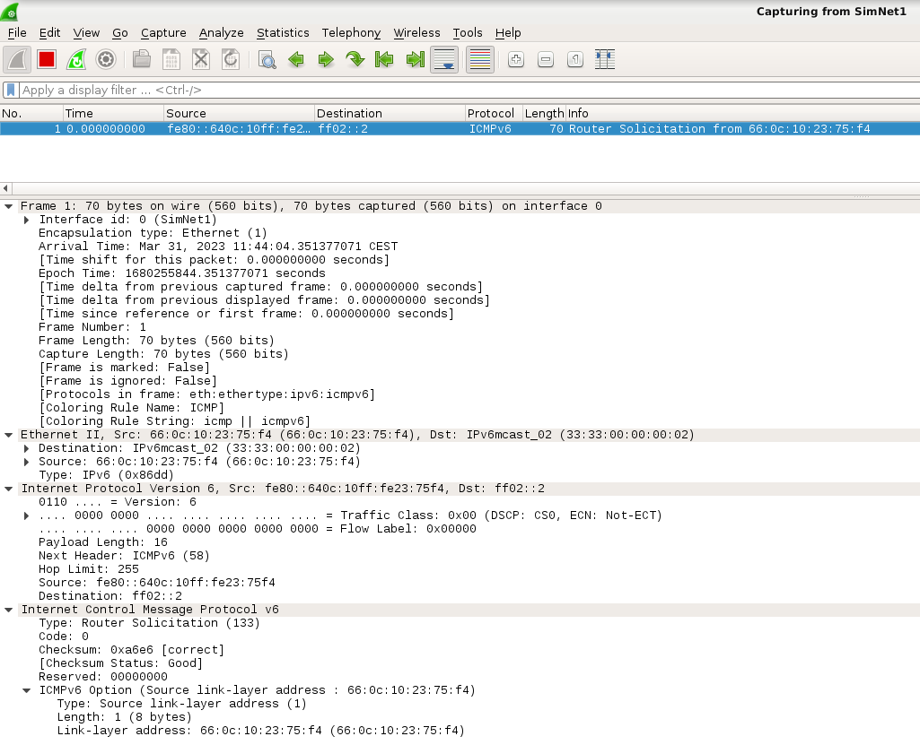
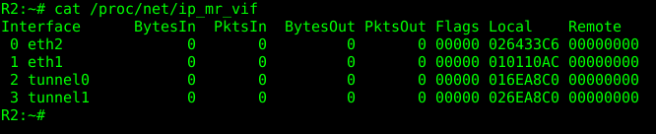
Ara surt la interfície eth1 ara està relacionada amb la multicast 232.43.211.234
This file /proc/net/ip_mr_vif will show you which are the interfaces which are able to use multicast in the multicast router, and some statistics of their use. As you have not sent any multicast packet, you will see that the statistics are empty.
Smcroute -a input_iface @origen @destion output_iface
      - Execute the following command in R2 to add a new multicast static route:
R2# smcroute −a eth1 0.0.0.0 232.43.211.234 tunnel0
This command will route IP datagrams entering through eth1 with any origin address and destination address the multicast group 232.43.211.234 towards the tunnel (so they will reach the other island).
      - Execute the following command to make R2 to join the entry interface eth1 to the multicast group 232.43.211.234:
R2# smcroute −j eth1 232.43.211.234
- View the content of the file /proc/net/igmp. What changes do you see in this file?
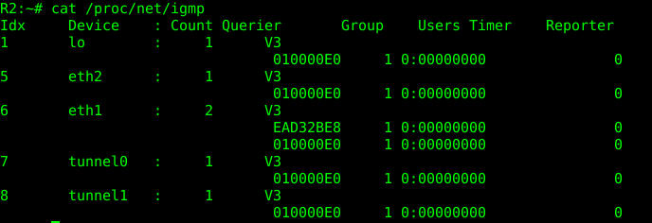
Connecta el tunnel0 al grup 232.43.211.234 (info) a través de la eth1.
- Have a look to SimNet3. Can you see any IGMP message in that interface?
A SN3 podem veure 2 paquets IGMP Membership Report / Joing grup 232.43.211.234 for any sources

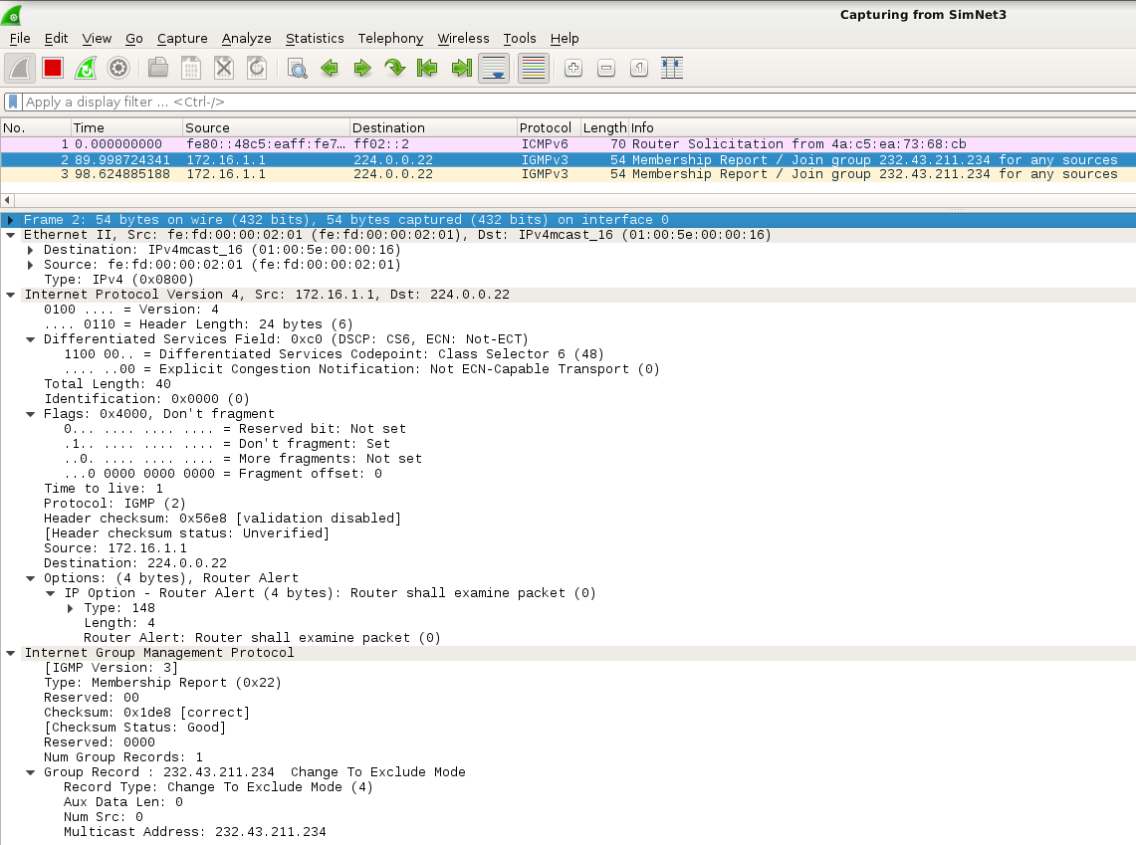
      - Now send a ping from server to the multicast group 232.43.211.234 with a scope of three hops.
server# ping −t3 −c1 232.43.211.234
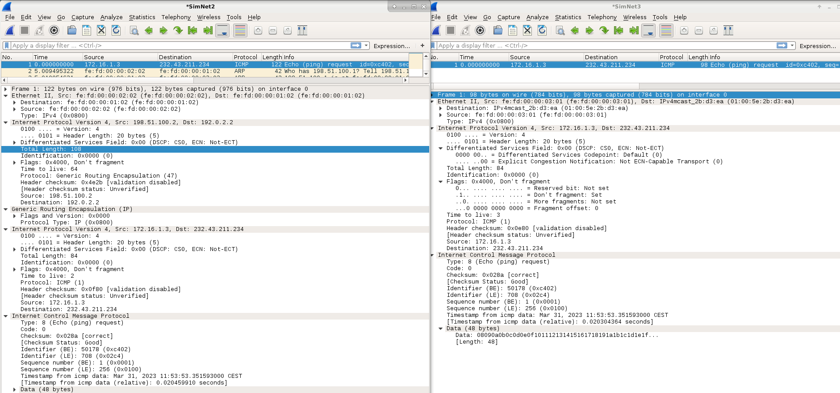
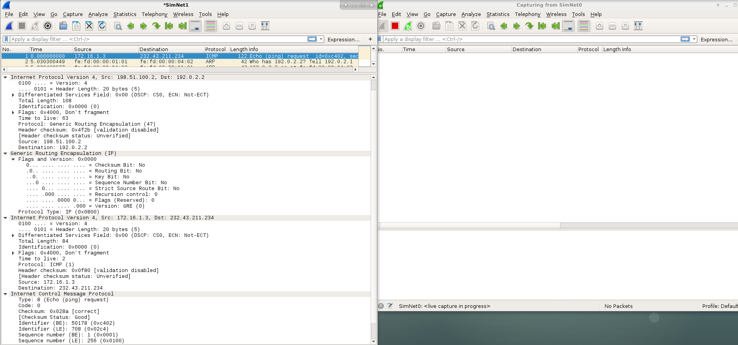
- Is the ping working? In which SimNets can you see ICMP packets?
No, is not working, there is 1 ICMP echo request in SN3, SN2, SN1 but not in SN0.
- Can you see any encapsulation in the ICMP packet in SimNet1 and SimNet2? What is the size of a GRE header?
A SN1/2 podem veure com el paquet ICMP està encapsulat (GRE). Hgre=4B
- Have a look again to file /proc/net/ip_mr_vif. Do you see any change in the statistics related to
tunnel0?

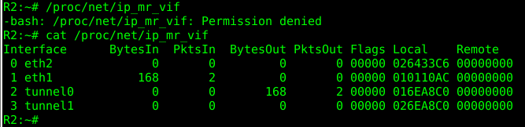

En el fitxer ip_mr_vif podem veure com els bytesIn de eth1 han augmentat i els BytesOut de tunnel0 també ho han fet
- Execute ip mroute show to see the Multicast Forwarding Cache. What is the meaning of all these parameters?
- Why do you think R1 is not forwarding the packet?
El R1 no reenvia el paquet a causa de que no està configurat com un router multicast i per tant, no pot processar i treure el ping cap a SN0.
According to wireshark, you will see that the packet has been introduced in the tunnel, but the decapsulator R1 has not been configured as multicast router, so the ICMP packet is not forwarded to SimNet0. Notice also that you have configured in R2 a unidirectional static multicast route, that is, from the server in SimNet3 to possible receivers in SimNet0.
      - Using smcroute, configure R1 to route IP datagrams entering through the tunnel with any origin address and destination address the multicast group 232.43.211.234 towards eth1. To do so, just follow the same procedure that you used in R2.
Fitxer a R2 i R1 smcrouteconfig.sh
R1#: smcroute -d
R1#: smcroute -a tunnel0 0.0.0.0 232.43.211.234 eth1
R1#: smcroute -j tunnel0 232.43.211.234
server#: ping -t3 -c1 232.43.211.234
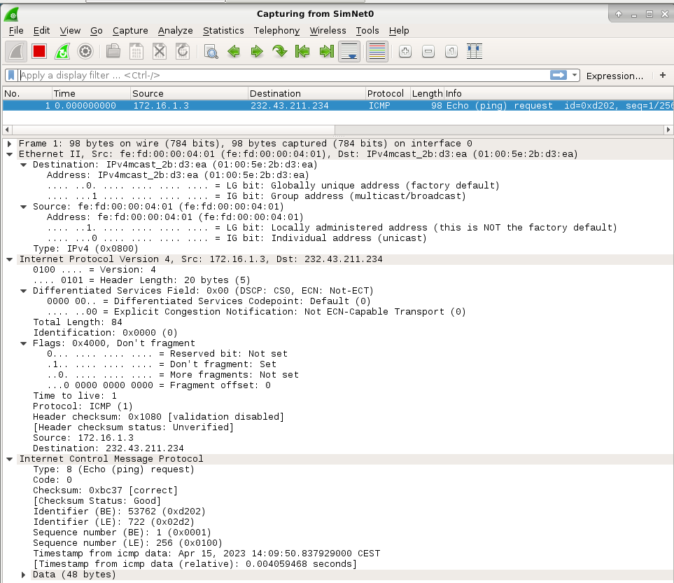
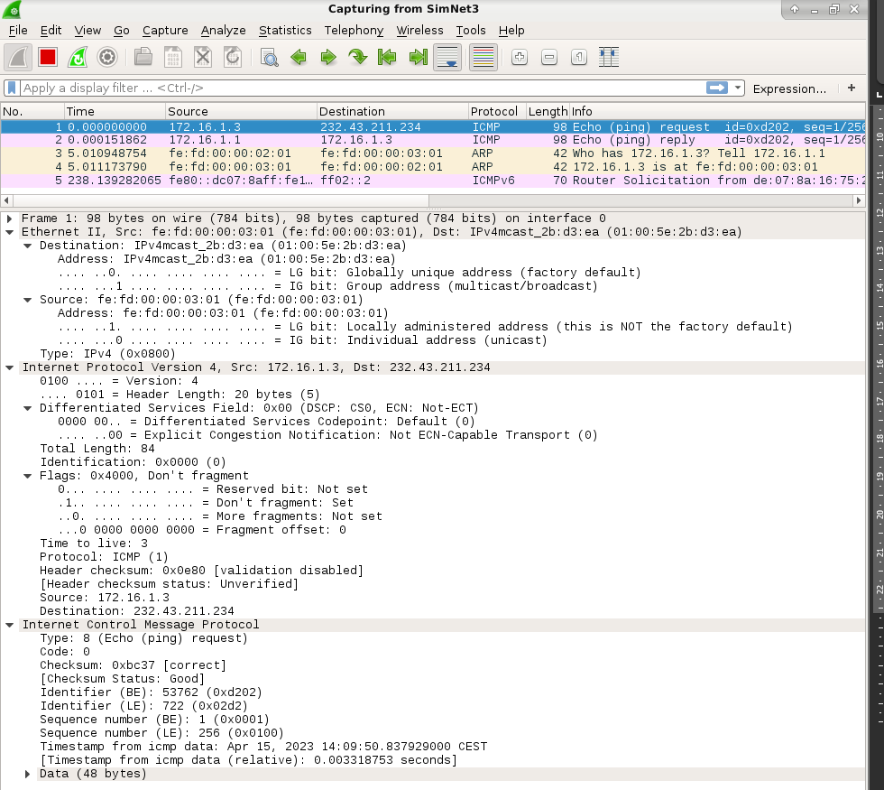

Com R1 ja ha estat configurat com a router multicast, el ping pot arribar al seu destí (hosts multicast) ja que R1 els pot redireccionar correctament.
- Can you see the packets in SimNet0? Which type of packets?
A SN0 podem veure 2 paquets IGMPv3 i un paquet ICMP echo-request
- Can you see any ICMP Echo Reply? Why?
A SN0 no podem veure cap ICMP reply, perquè no hi ha cap aplicació en funcionament al host destí que estigui preparada per contestar.
- Which is the TTL value of this packet in SimNet0?
El TTL d’aquest paquet és 1 al final, a SimNet0.
- If you send the same ping from server but with TTL=2, would it work?
Si enviem un ping al TTL=2, no funciona, i no podem veure cap ICMP echo-request a SN0 ni cap Time-to-Live exceeded in SN1 ( perque estem dins el tunnel0 i no s’apliquen els protocols) .
Quan enviem un ping al grup de control multicast des del servidor amb un TTL=3, podem veure el echo-request a SN0, encara que no hi ha cap missatge ICMP echo-reply. Amb un TTL=2, no podem arribar al destí, però amb un TTL=3 o superior si, encara que estem utilitzant més recursos dels necessaris, provocant un malbaratament d’aquests (BW, CPU, etc).
If you made the previous configuration properly, when you ping the multicast group from server with TTL=3, you will see the packet to reach SimNet0. If this is not happening, review the configuration because there is something wrong. There will be no ICMP Echo Reply message, as there is not an application running there ready to answer. Notice that it is important to define the proper scope for multicast packets. With TTL=2 you will not reach the destination. With TTL=4 or higher you will reach destination, but maybe you will also send packets to other networks that you did not pretend to reach, wasting resources (bandwidth, CPU, etc.). So be careful when defining the scope of your multicast packets.

Testing tools
You used smcroute to create a quite simplistic static multicast tree to connect SimNet3 to SimNet0. Once configured, you need ways to test if it works well. You previously used ping to do so, but ping is not an application that send real data. Also, there are some other problems that appear when using ICMP packets to test networks, just remember that some network administrators filter them just to avoid security attacks (you made some tests about this matter in the IP tunnel lab session).
So, here you will use two tools to test that multicast is working in the right manner.

ssmping
You are going to use the application ssmping, which allows you to verify both unicast and multicast routing. Have a look to the on-line manual of this program to become familiar with it. Basically, ssmping allows to verify if a host can receive SSM (Source Specific Multicast) packets from another host, by sending unicast and multicast UDP packets (remember that TCP does not support multicast traffic).
      - Put wiresharks listening in all the involved networks.
      - In console 0 of server start the daemon of the application executing the command
server# ssmpingd
When you consider necessary, use console 1 to control if server has joined to any new multicast group (use
netstat -gn).
      - In console 0 host2, execute the command:
host2# ssmping 172.16.1.3
When you consider necessary, use console 1 of host2 to control the same thing.
- What output can you see in host2? and in server?
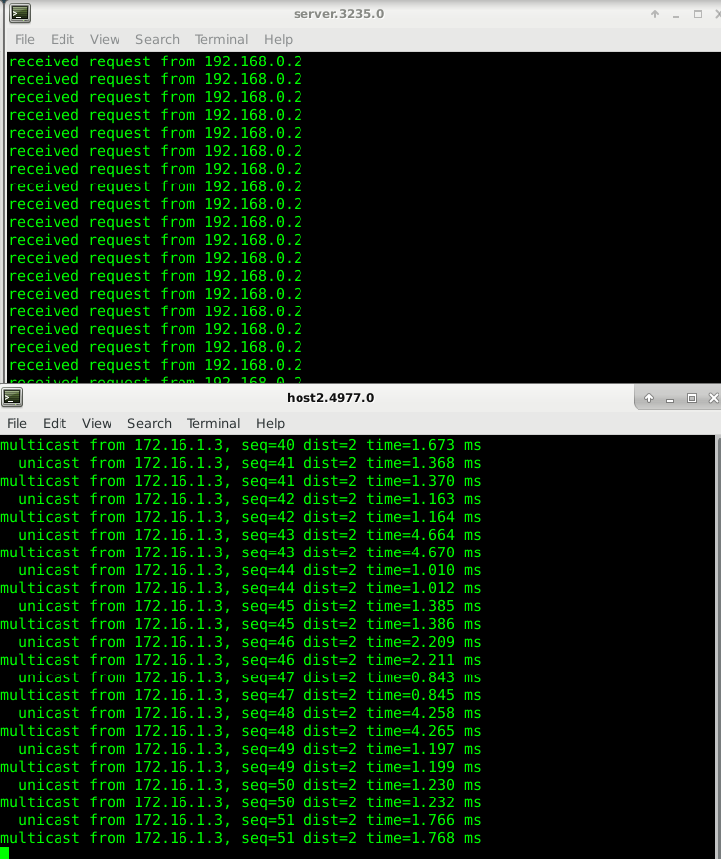
- In host 2 we can see the multicast data coming from 172.16.1.3 (server) and if we look if it has joins any new multicast group we observe how on eth1 has join the 224.0.0.1 and its connected to the channel 232.43.211.234.
- The server we can observe how he is receiving request from 192.168.0.2 (host2) and if we look if he is joining any multicast group, we observe how on eth1 he joins the 224.0.0.1 but he is not listening to any multicast channel
- According to this output, do you consider that the multicast routing is working?
According to this output the multicast routing form server host2 is working
Notice that ssmping is able to test both unicast and multicast routing. Have a look to the UDP packets. Notice that the behavior is periodical, and groups of three UDP packets are sent every second.
- What is the destination and origin address of the first packet? Is a unicast or multicast packet?
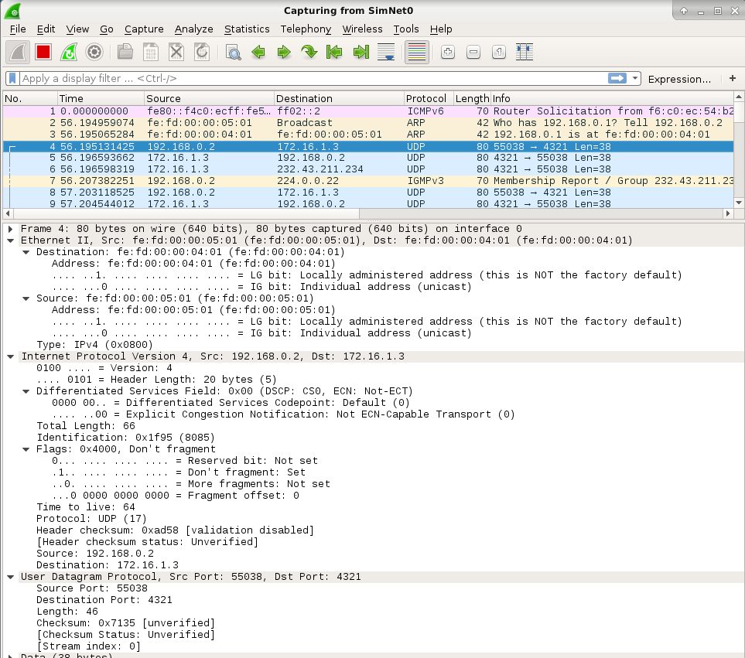
UNICAST - @IPsrc = 192.168.0.2 (host2) - @IPdst = 172.16.1.3 (server)
- And the second one? What is the purpose of these two packets?
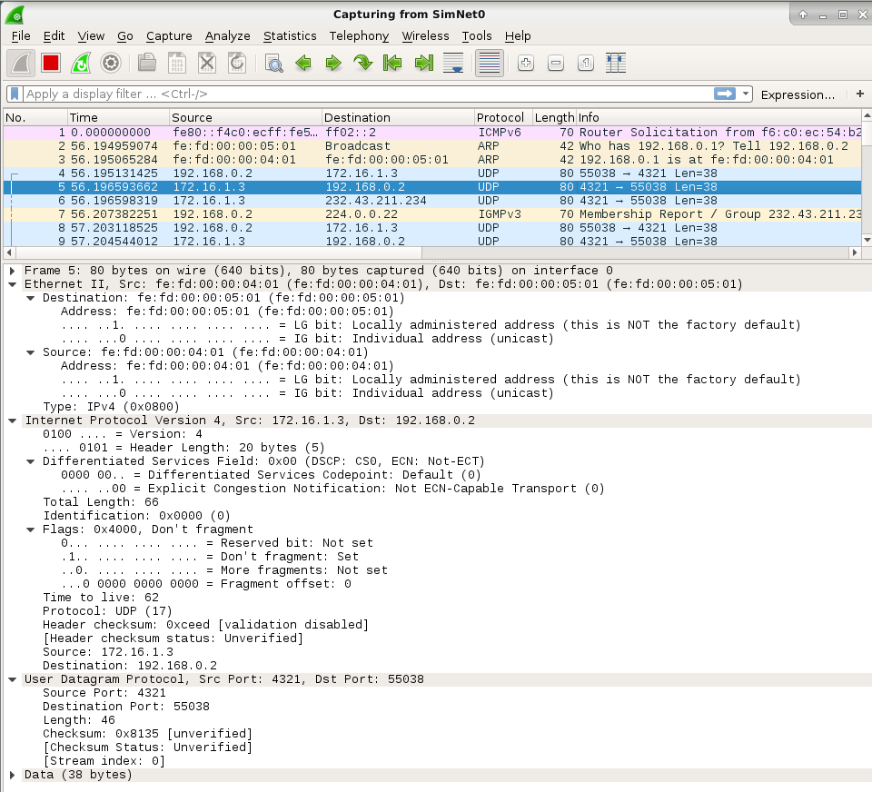
UNICAST - @IPsrc = 172.16.1.3 (server) - @IPdst= 192.168.0.2 (host2)
Purpose to connect with the source to as for the multicast address and the second one is the answer with the multicast address. As you can see arrive another packet with multicast address in the destination field but afterwards the host2 joins to the multicast group.
- Is the third packet different? Who is the origin and destination? Unicast or multicast? So, what is this packet testing? Unidirectional or bidirectional?
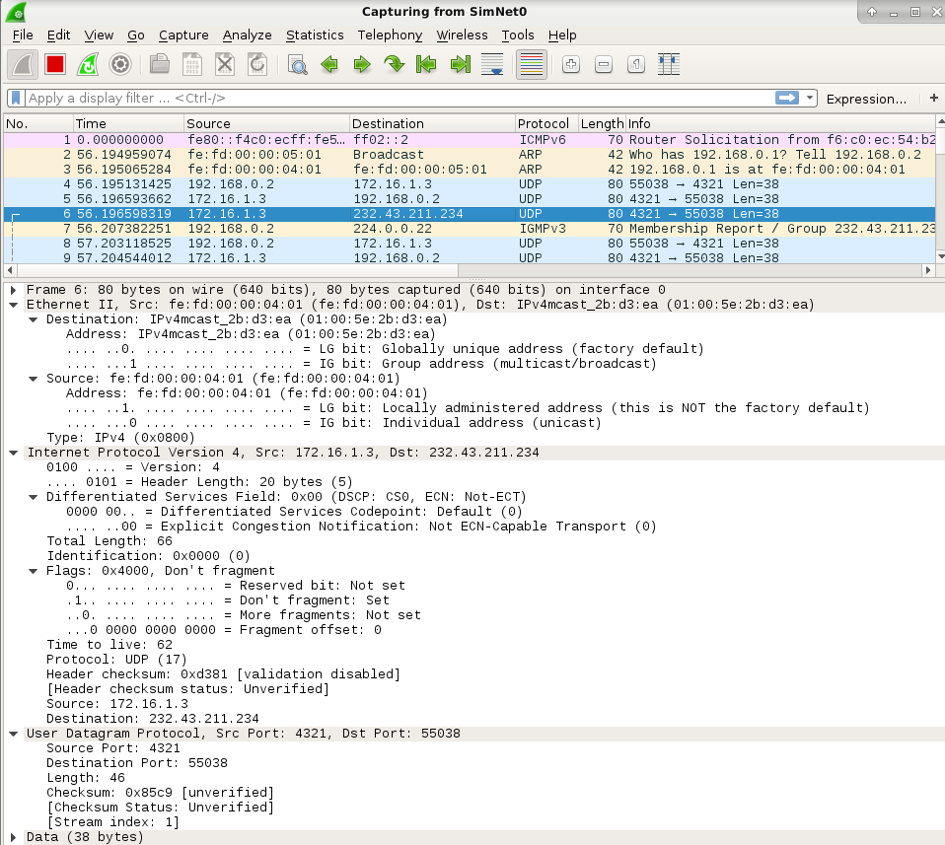
YES, MULTICAST PACKET - @IP_dst = 232.43.211.234 → multicast channel group
This frame is testing the undersection communication from the server to the host
Regarding IGMP packets:
- In SimNet0, can you see any IGMP Message? What kind of message? Which is the multicast group involved? (for easiness, put igmp in the Filter option available in the top-left corner of wireshark).
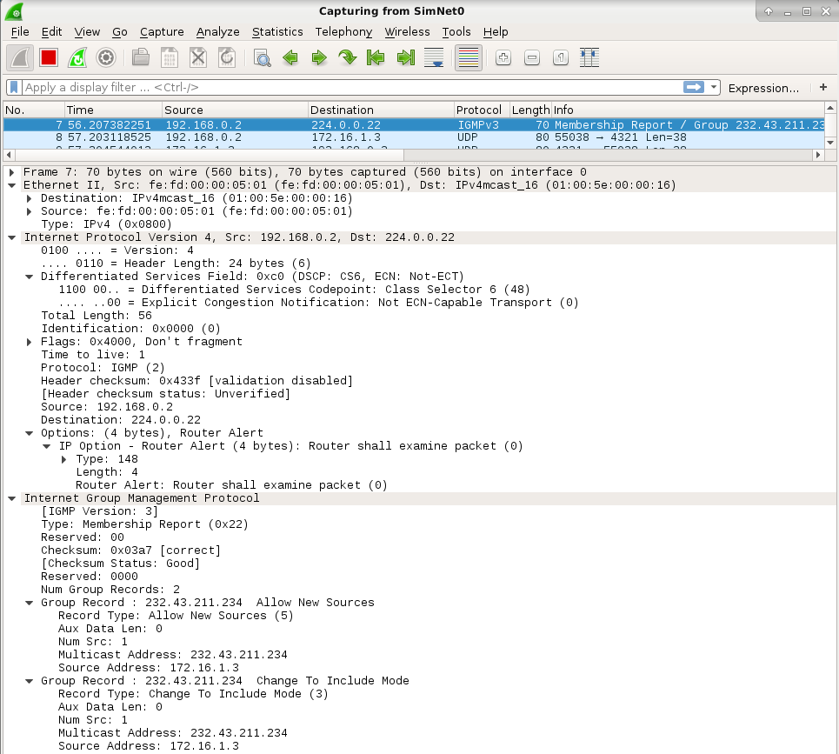
- Is this information coherent with what you see using netstat -gn?
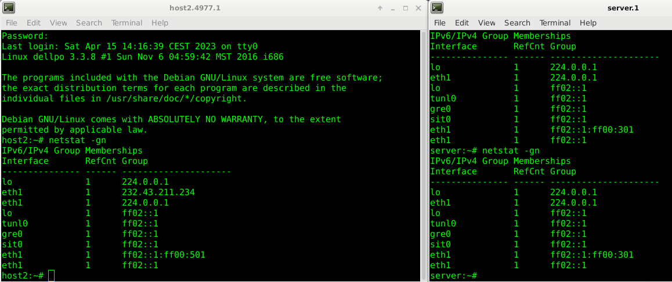
Yest as it is the same group
- Is there any other IGMP message in the rest of networks?
NO. Only the ones at the end when I stopped the TX to leave the group
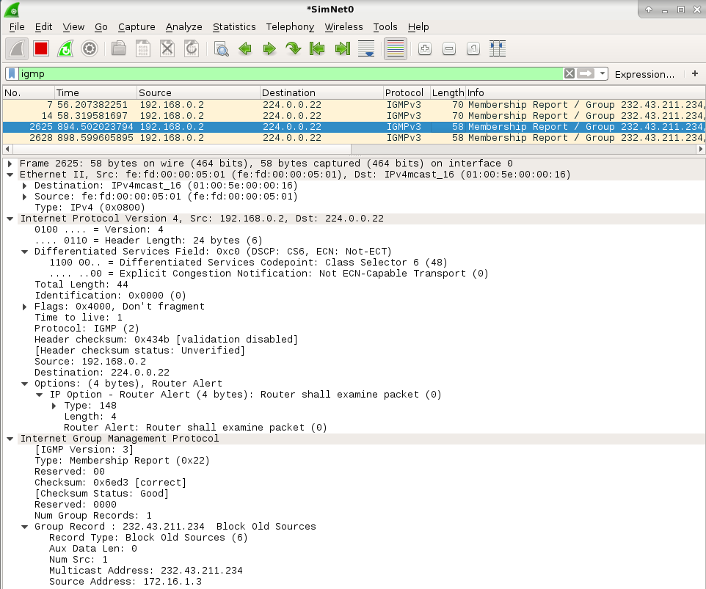
      - Now that you know what is the purpose of ssmping, and how it works, just test the same in the inverse direction (execute ssmping in server and ssmpingd in host2). Prior to execute the commands, try to foresee what is going to happen. Analyze the wireshark traces and extract your own conclusions.
If we do it in the other way you can see the unicast messages, and how no one is joining any new channel

mcsender and emcast (TO DO AT HOME)
It is also possible to verify the correct use of multicast static routing using the applications mcsender and emcast. Have a look to the manual of both applications to see how they work.
      - Put wiresharks listening in all the involved networks.
      - In server (acting as issuer) execute mcsender to send packets to the multicast group 232.43.211.234 using the UDP port 12345 with a scope of three hops.
server# mcsender -t3 232.43.211.234:12345
      - In host2 (acting as receiver) execute emcast to join group 232.43.211.234 using UDP port 12345.
host2# emcast 232.43.211.234:12345
- What output can you see in host2? and in server?
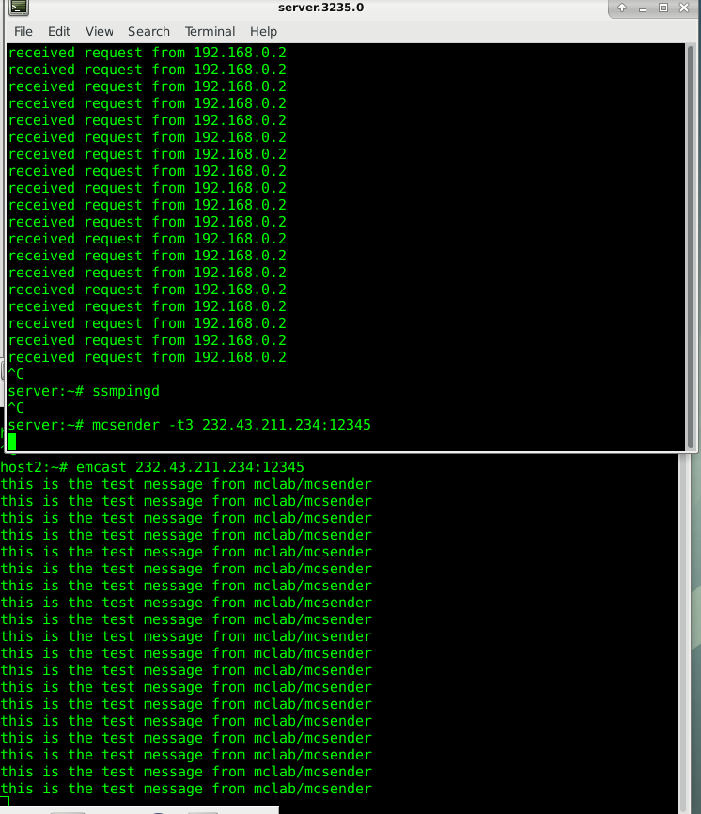
On host2 we can see the message sends by the sender. And how host2 has join the multicast channel 232.43.211.234
- According to this output, do you consider that the multicast routing is working?
The multicast routing form server → host2 is working
- What is the destination and origin address of the packets? Are they unicast or multicast?
The packets sent form the server are UDP multicast frames with Src: 172.16.1.3, Dst: 232.43.211.234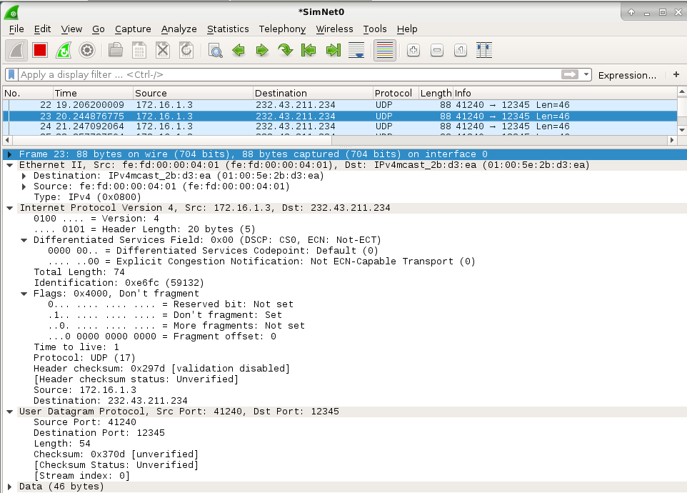
- Can you see any IGMP Message? Where? What kind of message? Which is the multicast group involved?
We can see the join and leave IGMPv3 join and leave messages on SimNet0 form host2. The group involved is 232.43.211.234.

Trees with multiple branches
So now you know how to create the multicast static routing tree to communicate the two multicast islands SimNet0 and SimNet3. But, what happens with the other island SimNet5? What should you do to create a tree with multiple branches? Your objective now is to create the multicast static routing tree necessary to perform a multicast transmission from server to receivers located at both SimNet0 and SimNet5.
The command smcroute allows us to create this configuration in an easy way, by only changing the configuration in R2.
      - Put wiresharks listening in all the involved networks.
      - Kill the smcroute daemon, so all previous configuration in that router will be lost
R2# smcroute −d
R2# smcroute −k
      - Start again the daemon smcroute.
      - Here you will see the main difference regarding the previous configuration. When adding the new multicast static route, instead of an only output interface, you can put a list of interfaces that will be used as output. So, execute the following command:
      - Join the entry interface eth1 to the multicast group 232.43.211.234:
R2# smcroute −j eth1 232.43.211.234
R2# smcroute −a eth1 0.0.0.0 232.43.211.234 tunnel0 tunnel1
      - Use ssmping to test the configuration, executing these commands:
server# ssmpingd
host2# ssmping 172.16.1.3
host4# ssmping 172.16.1.3
- Is ssmping working? What output message can you see in host2? host4? And in server?
Host2 → yes Unicast + Multicast
Host4 → only unicast
The ssmping is working as multicast for host2 which has been configured properly and as unicast for host4 who hasn’t been. The server is the source of multisource packets sent to host2 and host4, with this being shown in the server as received requests by the 2 hosts, and with unicast input shown in host2 and 4
- What will deduce from this output messages? What do you consider is missing?
R3 has no configuration allowing multicast enabled.
In order for multicast to work for host4, the same router setup must be done for R3 as it has been done for R2.
- Have a look to SimNet4, what type of messages can you see? unicast or multicast? And in SimNet5?
SN4 → unicast + multicast
SN5 → unicast mostly. No data in multicast. This confirms our theory that R3 is blocking the multicast traffic
Multicast messages travel along SimNet4, but get stopped by R3 as it is not configured properly
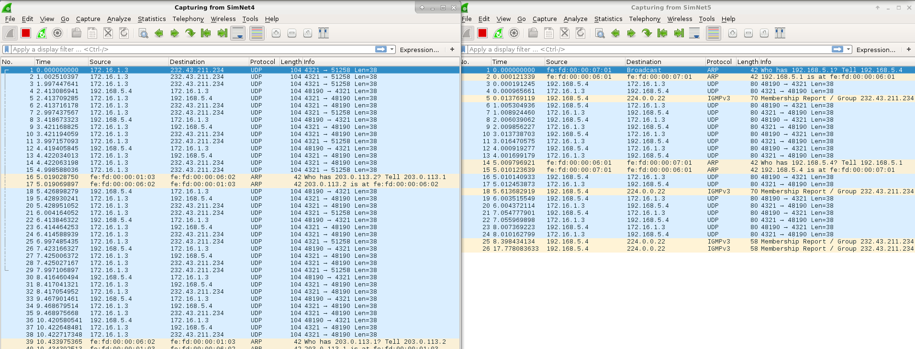
      - Make the necessary changes to make the multicast routing work so you can send a multicast flow from SimNet0
to both SimNet3 and SimNet5.
TO SOLVE IT: Configure R3 so it enables multicast traffic:
R3# smcroute −d
R3# smcroute −a tunnel1 0.0.0.0 232.43.211.234 eth1
R3# smcroute −j eth1 232.43.211.234
server# ssmpingd
host4# ssmping 172.16.1.3
Making the changes to allow proper unidirectional multicast along the 2 intended destinations. Keep in mind that the return path is not yet required, but if the case, each of these routers should also to have a smcroute -a between the eth1 to the respective tunnel.
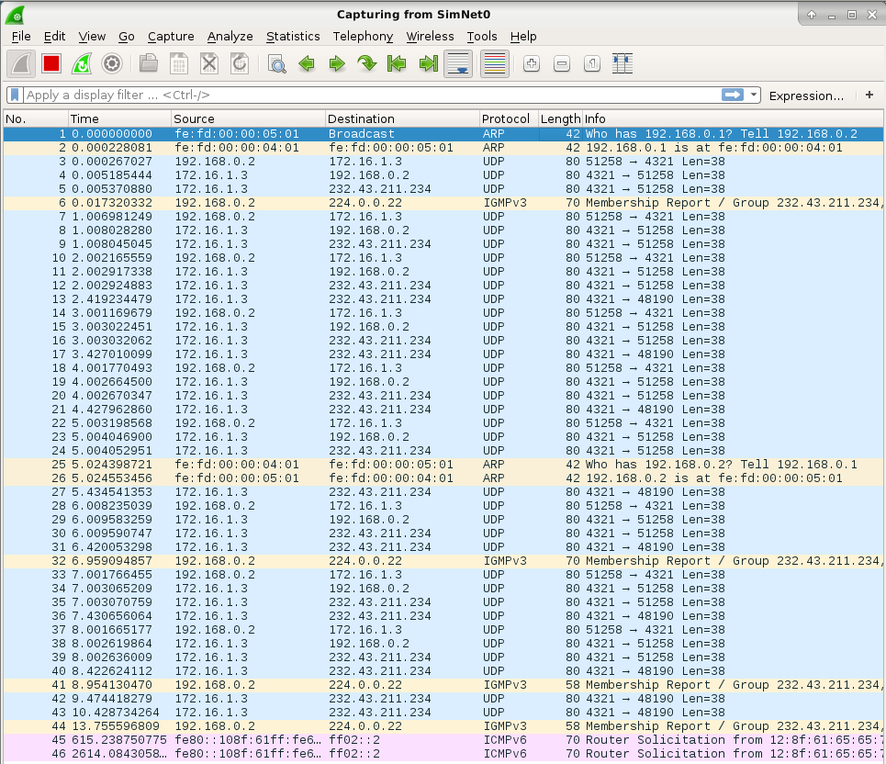
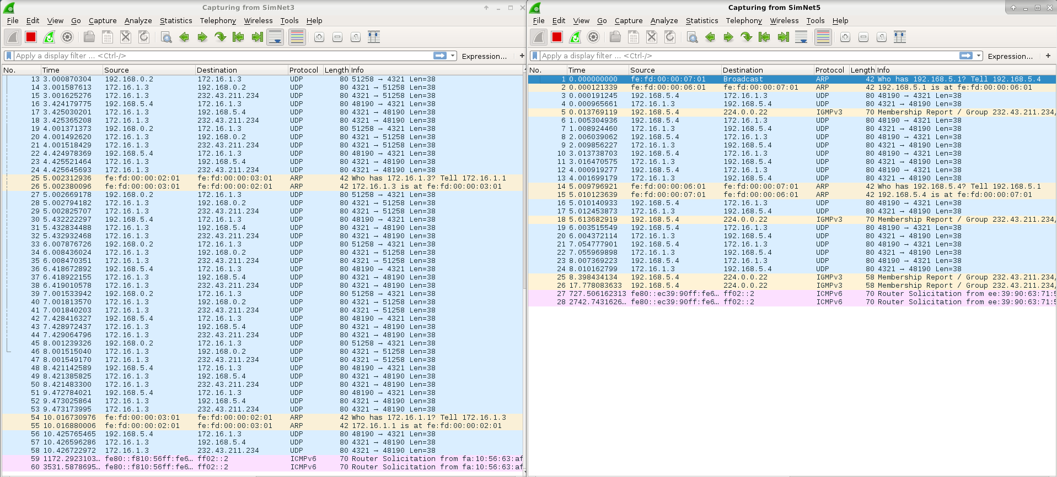
      - Test that the configuration is properly working, with ssmping.
      - Use also mcsender and emcast to test the configuration.
Now multicast packets are enabled. And we can observe how R2 joined multicast channel 232.43.211.234.

Sending the video
Now you are ready to make a real distribution of a video via multicast, but now between remote multicast islands. For the video distribution, you will use udp-sender and udp-receiver again. Remember that this software uses two multicast groups to enable the transmission: a multicast group to send data and a multicast group to control and add reliability to the transmission. In our case, you will use the multicast group 232.43.211.234 (previously configured in our scenario) to send data. As control group you will use 225.1.2.3.
      - Configure the multicast routers for the control group 225.1.2.3, exactly in the same way you did previously with the data group 232.43.211.234.
- R1# smcroute -a tunnel0 0.0.0.0 225.1.2.3 eth1
- R1# smcroute -j eth1 225.1.2.3
- R3# smcroute -d
- R3# smcroute -a tunnel1 0.0.0.0 225.1.2.3 eth1
- R3# smcroute -j eth1 225.1.2.3
- R2# smcroute -a eth1 0.0.0.0 225.1.2.3 tunnel0 tunnel1
- R2# smcroute -j eth1 225.1.2.3
Setting up the end tunnel routers for multicast with the new control group address: 225.1.2.3, as well as leaving the old control group possibility.
      - Test that this control group 225.1.2.3 is properly transmitted by the multicast tree from SimNet0 to both Sim- Net3 and SimNet5.
It works
      - Start udp-receiver in both host2 and host4:
host2# udp-receiver --file=big_664_in_host2.mpg --mcast-all-addr 225.1.2.3 --ttl 3 --interface eth1 --portbase 22345
host4# udp-receiver --file=big_664_in_host4.mpg --mcast-all-addr 225.1.2.3 --ttl 3 --interface eth1 --portbase 22345
      - Start upd-sender to transmit the video big_664.mpg from server. Remember that your multicast routing tree is unidirectional, and hence you will not receive any feedback from the receivers (for that reason we use the options autostart and max-bitrate. Notice also that you need to put the proper ttl and blocksize values to properly traverse the tunnels. Execute:
server# udp-sender --file=./big_664.mpg --portbase 22345 –nopointopoint --interface eth1 --ttl 3 --mcast-addr 232.43.211.234 --mcast-all-addr 225.1.2.3 --nokbd --async --max-bitrate 900K --autostart 1 --blocksize 1400
If the network is properly configured, you will see that the file is being transmitted via multicast and it is captured by both receivers. Once finished (after 2-3 minutes), a copy of the file should be stored in both host2 and host4. If you want to verify that these copies are equal to the one stored in server, you can use md5sum, which computes a MD5 hash of the file. The result of this md5sum must be the same in all the hosts.
server~# md5sum big_664.mpg
cf88e5d297fc7458e3914c224af4c06f big_664.mpg
Remember that the value may be different as we did not implement any reliability mechanism (there is no feedback to ask for retransmissions, and you do not use any FEC technique to correct errors).
Note that since the configuration has been done unidirectionally no response can come from the hosts, and this might cause quality loss (due to packet loss as there is no Forward error correction techniques implemented) as well as ICMP error messages.

Bidirectional tree (TO DO AT HOME)
Creating a bidirectional tree is mandatory to offer reliability to the multicast transmission. As we mentioned, we are not going to deal with reliable multicast, but you should be able to create this bidirectional tree using smcroute.
      - Configure the multicast routers to create this bidirectional tree for both data and control groups 232.43.211.234 and 225.1.2.3. Notice that in the previous section you created the forward tree (from server to host2 and host4). Now you only need to create the backward tree (from host2 and host4 to the server).
      - Start udp-receiver in both host2 and host4:
host2# udp-receiver --file=big_664_in_host2.mpg --mcast-all-addr 225.1.2.3 --ttl 3 --interface eth1 --portbase 22345
host4# udp-receiver --file=big_664_in_host4.mpg --mcast-all-addr 225.1.2.3 --ttl 3 --interface eth1 --portbase 22345
      - Start upd-sender to transmit the video big_664.mpg from server. Now the multicast routing tree is bidirectional, so we can receive feedback from receivers, and the options autostart and max-bitrate can be avoided as it is possible to establish a certain flow control between sender and receiver. Execute:
server# udp-sender --file=./big_664.mpg --portbase 22345 –nopointopoint --interface eth1 --ttl 3 --mcast-addr 232.43.211.234 --mcast-all-addr 225.1.2.3 --nokbd --autostart 1 --blocksize 1400
As there is no limitation in the bitrate, you will notice that the transmission is much more faster than in the previous case.
      - Using wireshark, have a look to the UDP packets sent towards the data multicast group.
- Are these UDP packets of maximum size?
Max size UDP → 1458B → it fills the hole MTU ( The UPD packets are 1458 at R3 and 1482 at R2)
- Do you know all the headers involved? Is there any header related to the application udp-sender?
It has the standard headers
- UDP → IPv4 → GER → IPv4 → Eth
- Which is the maximum value of the -blocksize option of udp-sender in order to traverse the tunnel with no problems?
Valor maxim de -blocksize: 1424B → MTU of the tunnel is 1476 -20 -4 -8 -20 = 1424.
The maximum value would be: 1500 – 20 (IP_tunnel) -4 (GRE) -20 (IP_regular) – 8 (UDP) = 1448B.
- Which percentage of packets are feedback packets?
More/less a 3% or 1.8% (1215/56432)
- Are these feedback packets unicast or multicast?
Feedback is unicast

Live streaming (TO DO AT HOME)
Until now you just sent files over the network, but notice that there are lots of applications using multicast that send information via streaming. So, you are going to send the same video via multicast from server to both host2 and host4, but at the same time your HOST machine will act as receiver playing the video in streaming. Prior to do this, you have to prepare your HOST machine to interact with the virtualized scenario. Next, we are going to provide some guidelines to play this video in streaming, but this should be considered as an example, and you may need to adapt the commands to the particular configuration of your HOST machine.
      - First thing to do, you will need to install in your HOST machine udpcast⁵, which includes udp-sender and udp-receiver. Notice that the version of udpcast that you are installing in your HOST machine may be different to the one installed in the virtual machines.
      - You will also need a video player that allows to play in streaming, for instance vlc⁶.
      - Next, you have to configure the interface you are going to use in your HOST machine to interact with the virtualized scenario. Using ifconfig, assign the IP address 172.16.1.4 to SimNet3.
      - Using route, create a new route to send the range 224.0.0.0/4 to SimNet3 (if not, multicast packets will be sent towards the default route).
      - Execute udp-receiver in host2 and host4.
host2# udp-receiver --file=big_664_in_host2.mpg --mcast-all-addr 225.1.2.3 --ttl 3 --interface eth1 --portbase 22345
host4# udp-receiver --file=big_664_in_host4.mpg --mcast-all-addr 225.1.2.3 --ttl 3 --interface eth1 --portbase 22345
      - Execute udp-receiver in your HOST machine, but redirecting the output of this application to the input video player vlc. As we mentioned, maybe you will need to adapt the command to the particular characteristics of your HOST machine. So, just as an example, execute:
HOST$ udp-receiver --nokbd --mcast-rdv-address 225.1.2.3 --ttl 1 --interface SimNet3 --portbase 22345 | vlc --file-caching 0 - 2>/dev/null
Notice that the option -mcast-rdv-address of this upd-receiver is different from the one used previ- ously (-mcast-all-addr), because the versions of udpcast are different.
      - Finally, execute udp-sender at server:
server# udp-sender --file=./big_664.mpg --portbase 22345 –nopointopoint --interface eth1 --ttl 3 --mcast-addr 232.43.211.234 --mcast-all-addr 225.1.2.3 --nokbd --autostart 1 --blocksize 1400
If everything is properly configured, the file will be transmitted via multicast from server to the three receivers:
host2 and host4 receiving the file, and HOST playing in streaming the video.

The end of the overlay (TO DO AT HOME)
We mentioned that the configuration of this scenario pretends to be similar to the one used for the gradual deployment of the multicast technology (MBONE). In fact, there are other examples in which an overlay was constructed to help during the deployment of a new technology, connecting islands by using tunneling and encapsulation (for instance, the slow deployment of the IPv6 protocol). As time goes by, there are more nodes into the overlay (because they are aware of the new technology, for instance multicast), and few out of it. Finally, it is expected that all nodes are able to understand the new technology, so the overlay may have no sense (nor the tunnels).
To try to test this, let us try to translate this same idea to our multicast scenario. At the beginning we mentioned that RC was not a multicast router, so it was not possible for this router to be part of the multicast tree. Instead, you used IP tunnels to construct an overlay of multicast routers, bypassing RC by means of the GRE tunnels. This overlay works well, but you know that it is not totally transparent, and in fact there are some performance problems. For instance, every time you send a message through the multicast tree, this message is sent twice in SimNet2 (one through tunnel0 and another one through tunnel1), wasting bandwidth. You should have noticed this, this design is not able to use the network infrastructure efficiently and to achieve one of the main requirements of multicast: “messages must be sent only once over each link of the network“. Anyway, the overlay works pretty well, and this is just one more of the side effects caused by the use of tunneling techniques (overhead caused by the tunnel headers, MTU problems, TTL, etc.).
Now consider that RC evolves technologically, and now it is able to be a multicast router. So, it should be included as part of the multicast tree. In fact, now all routers are multicast routers, and the overlay and the tunnels do not have any sense.
So, as a final exercise for this lab session, include RC in the multicast tree and send again the video from server
to the two receivers: host2 and host4
      - Delete the static multicast tree by killing smcroute in all the multicast routers. Instead of doing it manually, execute the following command in your HOST:
HOST$ simctl ipmulticast exec mcclean
      - Delete the tunnels by executing the following command in your HOST:
HOST$ simctl ipmulticast exec deltun
Notice that deleting the tunnels means that you cannot access to the private networks (using unicast).
      - Use smcroute to create a tree from SimNet3 to SimNet0 and SimNet5. Notice that the tunnels do not exist, and RC should be included in the multicast tree.
- How many commands did you execute in every router?
A cada route rhe ejectuat un minim de 3, un màxim de 8 (a RC)
- Do you think that static multicast routing is worthy? What would happen in case of having much more routers to configure?
El multicast routing static es worthy quan la xarxa ´s petita, tot I així, a la que es fa una mica gran el # de cmd augmenta i és per això que és preferible l’enroutament dinamic multicast
      - Use udp-sender and udp-receiver to make the video transmission.
- How many times the same flow is sent over each link?
- What is now the maximum block size allowed in udp-sender?
- And the TTL?
- Can you use a bidireccional transmission (with feedback information)?
- In terms of performance, do you think that this solution works better than the overlay?
As you can see, you have executed several commands to make this configuration possible. Multicast static routing is easy to configure and to understand in case of having small networks, but obviously is not an scalable option in case of having mid to large network topologies. In that case, dynamical multicast routing protocols like Protocol Independent Multicast (PIM) should be used. We are not going to deal with dynamical multicast routing in this lab session. We hope that all these experiments helped you to understand how complicated is to understand multicast, even in this simplistic scenario with only some few routers.

IGMP messages are encapsulated in IP datagrams, with an IP protocol number of 2.
There are three types of IGMP messages of concern to the host-router interaction:

0x11 = Membership Query
There are two sub-types of Membership Query messages:
- General Query, used to learn which groups have members on an
attached network.
- Group-Specific Query, used to learn if a particular group
has any members on an attached network.

These two messages are differentiated by the Group Address, as
described in section 1.4 . Membership Query messages are
referred to simply as "Query" messages.

0x16 = Version 2 Membership Report
0x17 = Leave Group
There is an additional type of message, for backwards-compatibility
with IGMPv1:
0x12 = Version 1 Membership Report
---------------
The Max Response Time field is meaningful only in Membership Query
messages, and specifies the maximum allowed time before sending a
responding report in units of 1/10 second. In all other messages, it
is set to zero by the sender and ignored by receivers.

2.4. Group Address
In a Membership Query message, the group address field is set to zero when sending a General Query, and set to the group address being queried when sending a Group-Specific Query. In a Membership Report or Leave Group message, the group address field holds the IP multicast group address of the group being reported or left.

(traduccion:
En un mensaje de consulta de afiliación, el campo de dirección de grupo se pone a cero cuando se envía una consulta general, y a la dirección del grupo que se Cuando se envía una consulta específica de grupo, se establece la dirección del grupo que se está consultando.
En un mensaje de informe de pertenencia o de abandono de grupo, el campo de dirección de grupo grupo contiene la dirección de grupo de multidifusión IP del grupo que se que se está informando o abandonando.)

Multicast routers use IGMP to learn which groups have members on each of their attached physical networks. A multicast router keeps a list of multicast group memberships for each attached network, and a timer for each membership. "Multicast group memberships" means the presence of at least one member of a multicast group on a given attached network, not a list of all of the members.
a multicast router may assume one of two roles: Querier or Non-Querier. There is normally only one Querier per physical network. All multicast routers start up as a Querier on each attached network. If a multicast router hears a Query message from a router with a lower IP address, it MUST become a Non-Querier on that network. If a router has not heard a Query message from another router for [Other Querier Present Interval], it resumes the role of Querier. Routers periodically [Query Interval] send a General Query on each attached network for which this router is the Querier, to solicit membership information. On startup, a router SHOULD send [Startup Query Count] General Queries spaced closely together [Startup Query Interval] in order to quickly and reliably determine membership information. A General Query is addressed to the all-systems multicast group (224.0.0.1), has a Group Address field of 0, and has a Max Response Time of [Query Response Interval].

When a host receives a Group-Specific Query, it sets a delay timer to a random value selected from the range (0, Max Response Time]. → When a group's timer expires, the host multicasts a Version 2 Membership Report to the group, with IP TTL of 1. If the host receives another host's Report (version 1 or 2) while it has a timer running, it stops its timer for the specified group and does not send a Report, in order to suppress duplicate Reports.

When a host joins a multicast group, it should immediately transmit an unsolicited Version 2 Membership Report for that group, in case it is the first member of that group on the network. To cover the possibility of the initial Membership Report being lost or damaged, it is recommended that it be repeated once or twice after short delays.

When a host leaves a multicast group, if it was the last host to reply to a Query with a Membership Report for that group, it SHOULD send a Leave Group message to the all-routers multicast group (224.0.0.2). If it was not the last host to reply to a Query, it MAY send nothing as there must be another member on the subnet.

Non-Queriers MUST ignore Leave Group messages, and Queriers SHOULD ignore Leave Group messages for which there are no group members on the reception interface.
When a non-Querier receives a Group-Specific Query message, if its existing group membership timer is greater than [Last Member Query Count] times the Max Response Time specified in the message, it sets its group membership timer to that value.

Host behavior is more formally specified by the state transition diagram below. A host may be in one of three possible states with respect to any single IP multicast group on any single network interface:
- "Non-Member" state, when the host does not belong to the group on the interface. This is the initial state for all memberships on all network interfaces; it requires no storage in the host.
- "Delaying Member" state, when the host belongs to the group on the interface and has a report delay timer running for that membership.
- "Idle Member" state, when the host belongs to the group on the interface and does not have a report delay timer running for that membership.

There are five significant events that can cause IGMP state transitions:
- "join group" occurs when the host decides to join the group on the interface. It may occur only in the Non-Member state.
- "leave group" occurs when the host decides to leave the group on the interface. It may occur only in the Delaying Member and Idle Member states.

- "query received" occurs when the host receives either a valid General Membership Query message, or a valid Group-Specific Membership Query message. To be valid, the Query message must be at least 8 octets long, and have a correct IGMP checksum. The group address in the IGMP header must either be zero (a General Query) or a valid multicast group address (a Group-Specific Query). A General Query applies to all memberships on the interface from which the Query is received. A Group-Specific Query applies to membership in a single group on the interface from which the Query is received. Queries are ignored for memberships in the Non-Member state.
- "report received" occurs when the host receives a valid IGMP Membership Report message (Version 1 or Version 2). To be valid, the Report message must be at least 8 octets long and have a correct IGMP checksum. A Membership Report applies only to the membership in the group identified by the Membership Report, on the interface from which the Membership Report is received. It is ignored for memberships in the Non-Member or Idle Member state.
- "timer expired" occurs when the report delay timer for the group on the interface expires. It may occur only in the Delaying Member state.

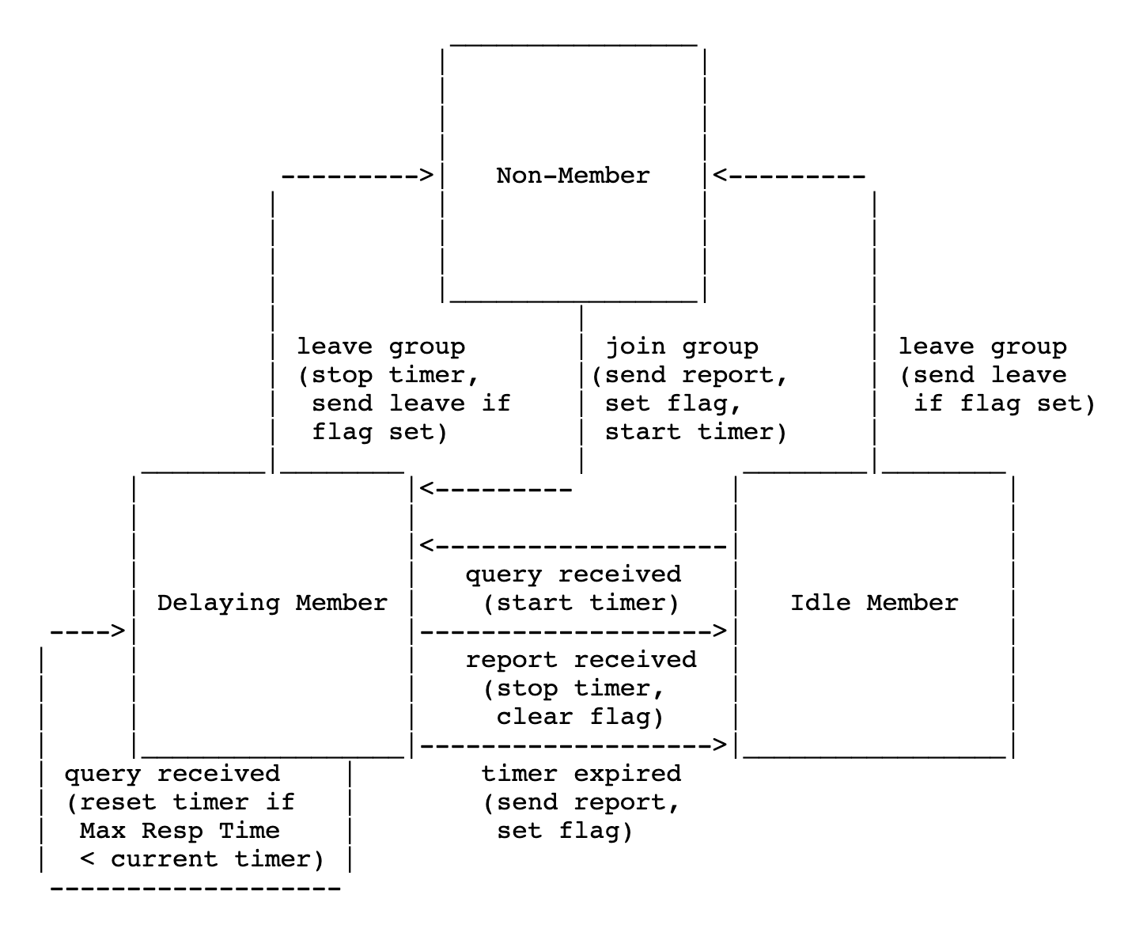
The all-systems group (address 224.0.0.1) is handled as a special case. The host starts in Idle Member state for that group on every interface, never transitions to another state, and never sends a report for that group.

A router may be in one of two possible states with respect to any single attached network:
- "Querier", when this router is designated to transmit IGMP Membership Queries on this network.
- "Non-Querier", when there is another router designated to transmit IGMP membership Queries on this network.
The following three events can cause the router to change states:
- "query timer expired" occurs when the timer set for query transmission expires.
- "query received from a router with a lower IP address" occurs when an IGMP Membership Query is received from a router on the same network with a lower IP address.
- "other querier present timer expired" occurs when the timer set to note the presence of another querier with a lower IP address on the network expires.
There are three actions that may be taken in response to the above events:
- "start general query timer" for the attached network.
- "start other querier present timer" for the attached network [Other
Querier Present Interval].
- "send general query" on the attached network. The General Query is sent to the all-systems group (224.0.0.1), and has a Max Response Time of [Query Response Interval].
A router should start in the Initial state on all attached networks, and immediately move to Querier state.

keep track of which groups have members,
- No Members Present" state, when there are no hosts on the network which have sent reports for this multicast group. This is the initial state for all groups on the router; it requires no storage in the router.
- "Members Present" state, when there is a host on the network which has sent a Membership Report for this multicast group.
- "Version 1 Members Present" state, when there is an IGMPv1 host on the network which has sent a Version 1 Membership Report for this multicast group.
- "Checking Membership" state, when the router has received a Leave message but has not yet heard a Membership Report for the multicast group.

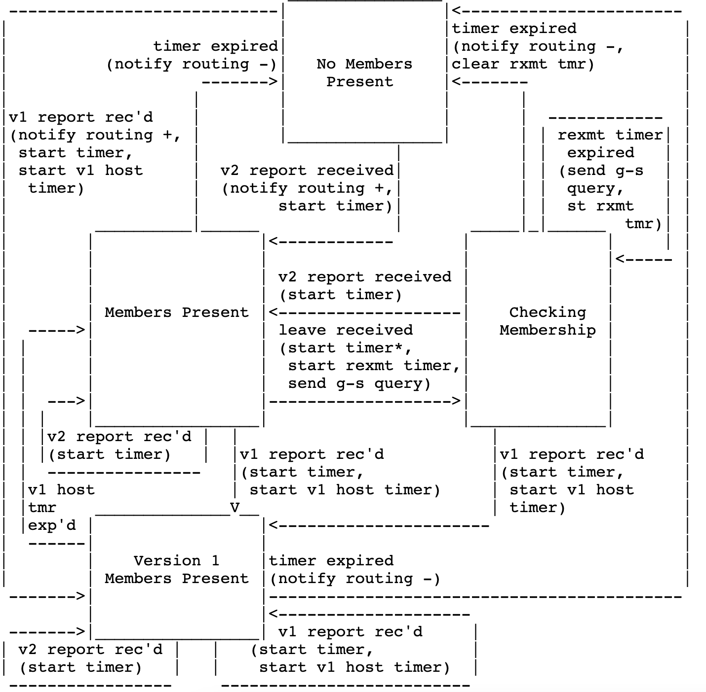

The state diagram for a router in Non-Querier state is similar, but non-Queriers do not send any messages and are only driven by message reception.Note that non-Queriers do not care whether a Membership Report message is Version 1 or Version 2.

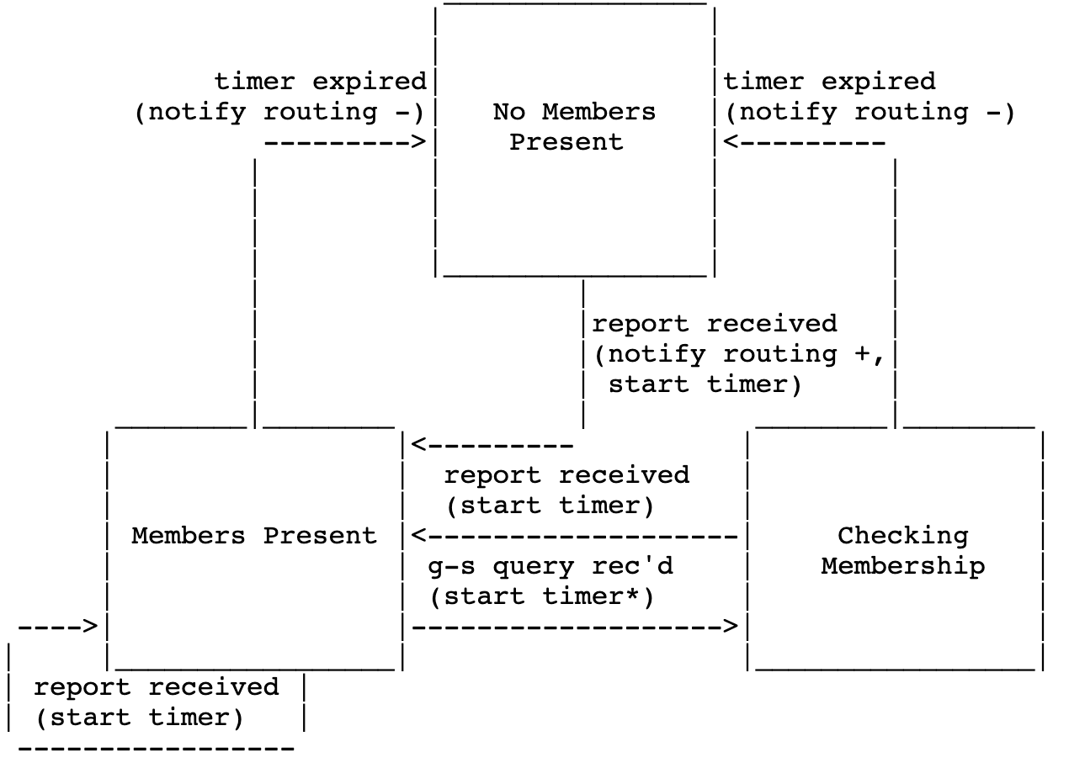
The Group Membership Interval is the amount of time that must pass before a multicast router decides there are no more members of a group on a network. This value MUST be ((the Robustness Variable) times (the Query Interval)) plus (one Query Response Interval).

The Last Member Query Interval is the Max Response Time inserted into Group-Specific Queries sent in response to Leave Group messages, and is also the amount of time between Group-Specific Query messages. Default: 10 (1 second)
This value may be tuned to modify the "leave latency" of the network. A reduced value results in reduced time to detect the loss of the last member of a group.
Message Type Destination Group
------------ -----------------
General Query ALL-SYSTEMS (224.0.0.1)
Group-Specific Query The group being queried
Membership Report The group being reported
Leave Message ALL-ROUTERS (224.0.0.2)

numero de protocolo en la cabecera ip: 2(IGMP)
numero de protocolo de la outer header cuando lo metemos por el tunnel: 47 GRE
The range of addresses 224.0.0.0/24 is also reserved by the IANA for Link-Local multicast addresses, that is to say, addresses reserved to be used in the local subnet. To do so, these packets are sent with TTL=1, so routers do not forward them to other networks.
For instance,
- The address 224.0.0.1 identifies all-hosts.
- The address 224.0.0.2 identifies all routers.
The range of addresses 239.0.0.0/24 is known as Administratively Scoped, meaning that these addresses can be used in private domains (same idea than private unicast addressing).
RFC 1112 says: An ICMP error message (Destination Unreachable, Time Exceeded, Parameter Problem, Source Quench, or Redirect) is never generated in response to a datagram destined to an IP host group.

For instance, every time you send a message through the multicast tree, this message is sent twice in SimNet2 (one through tunnel0 and another one through tunnel1), wasting bandwidth. You should have noticed this, this design is not able to use the network infrastructure efficiently and to achieve one of the main requirements of multicast: “messages must be sent only once over each link of the network“.

